**Reference:**

<https://www.youtube.com/watch?v=X48VuDVv0do&t=71s>

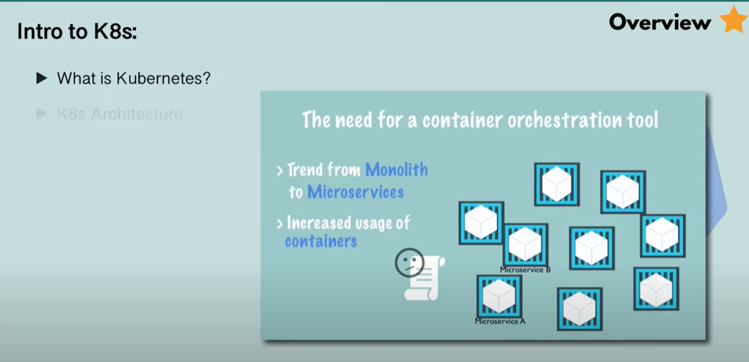

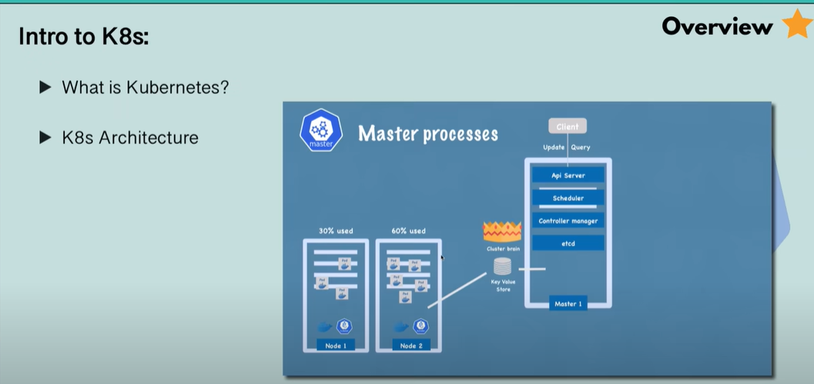

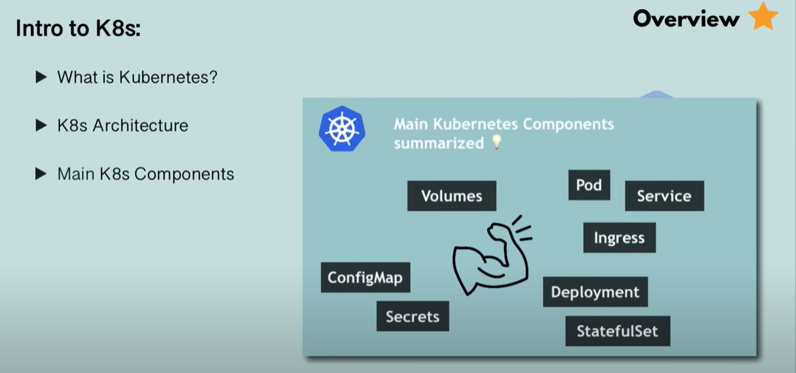

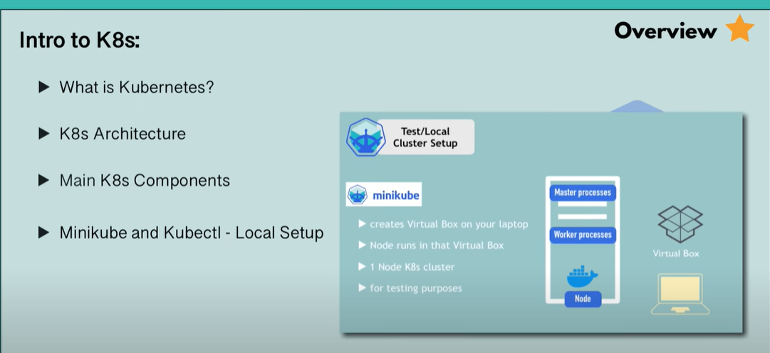

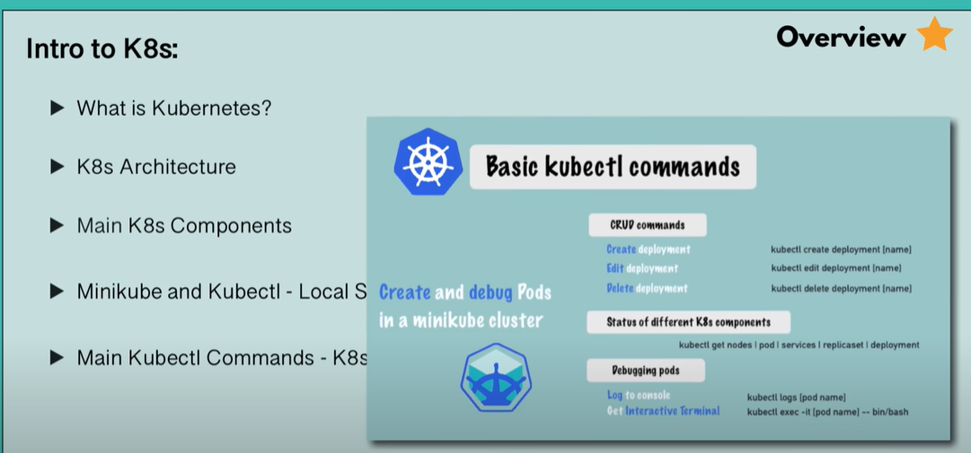

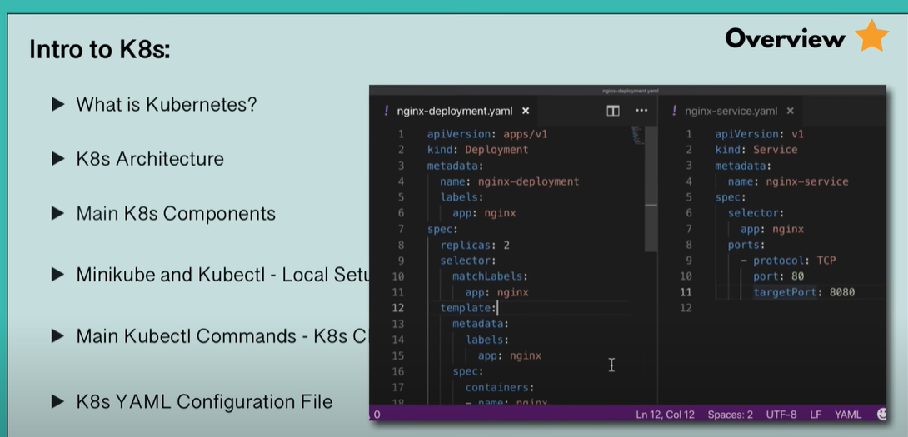

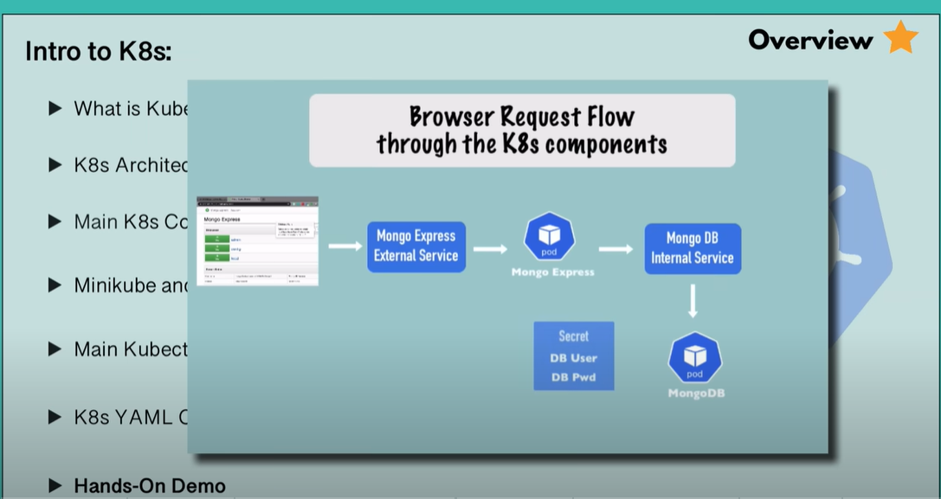

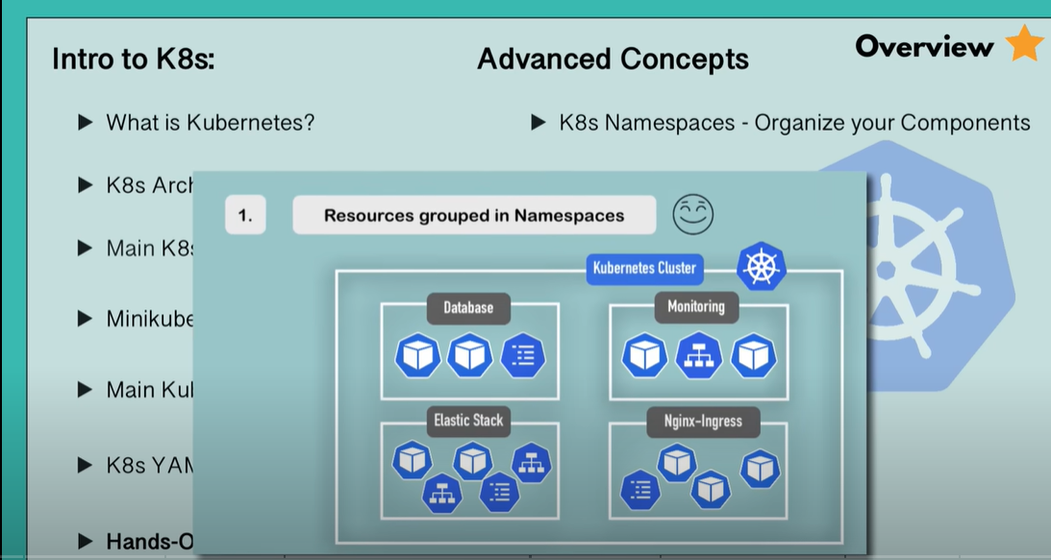

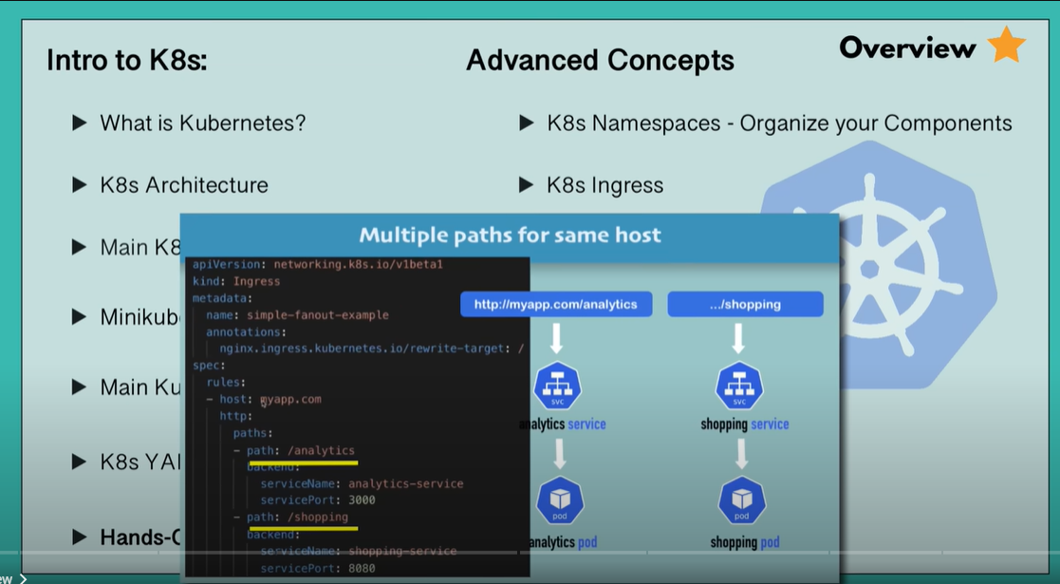

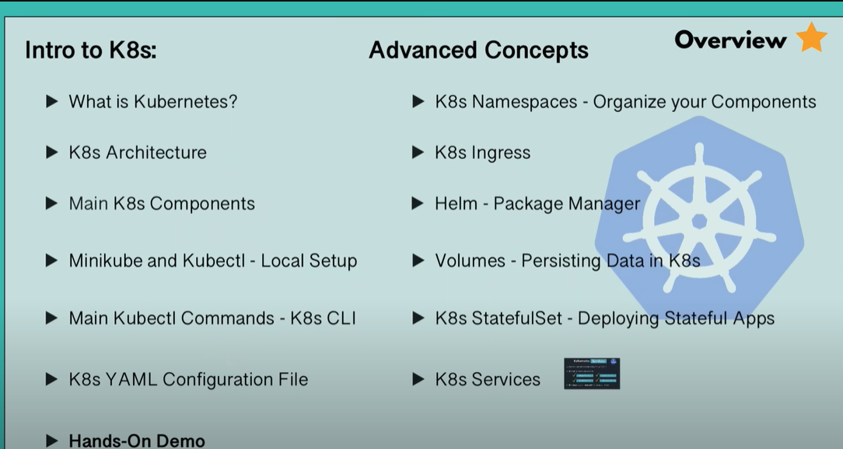

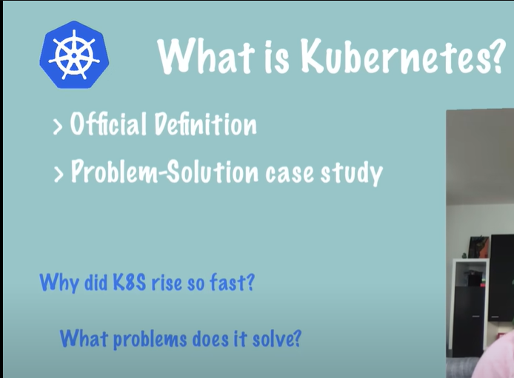

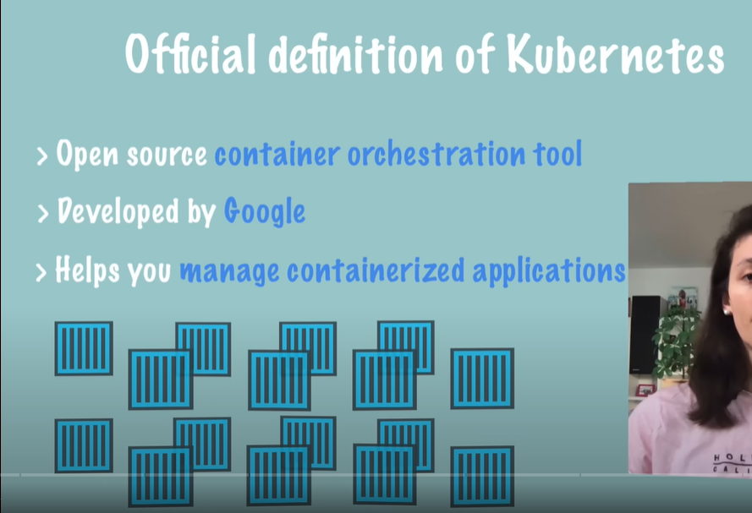

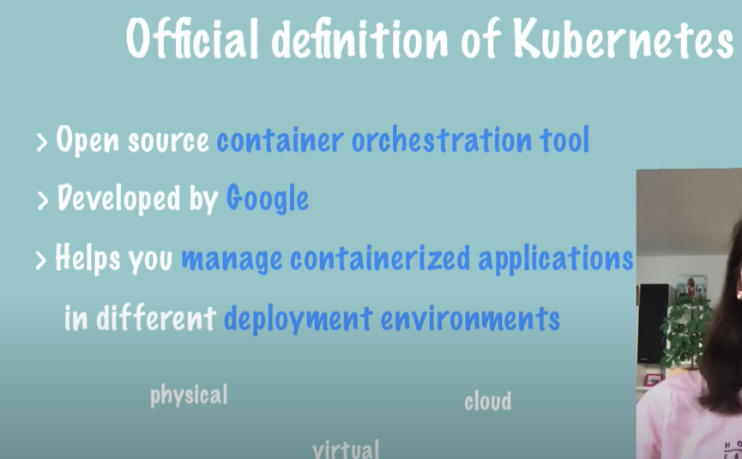

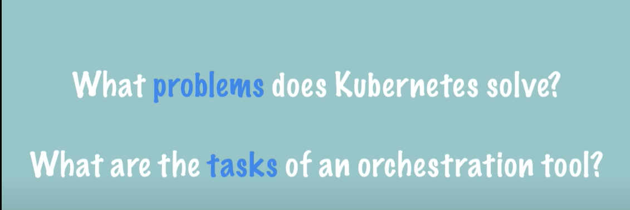

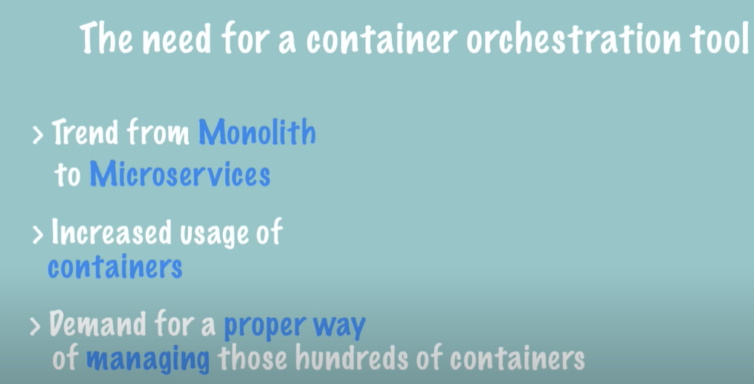

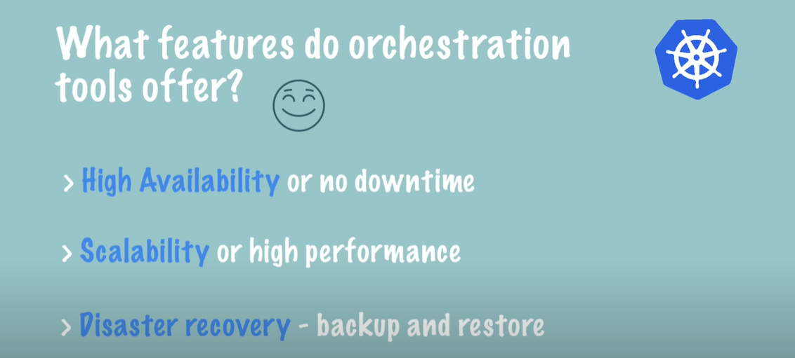

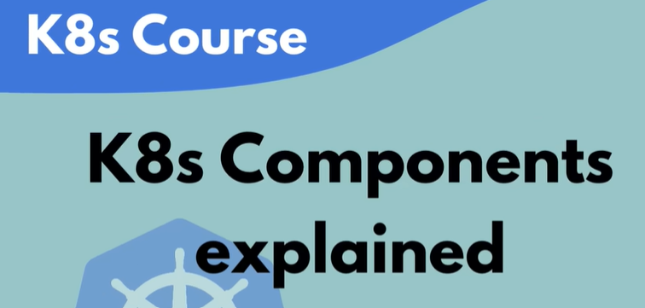

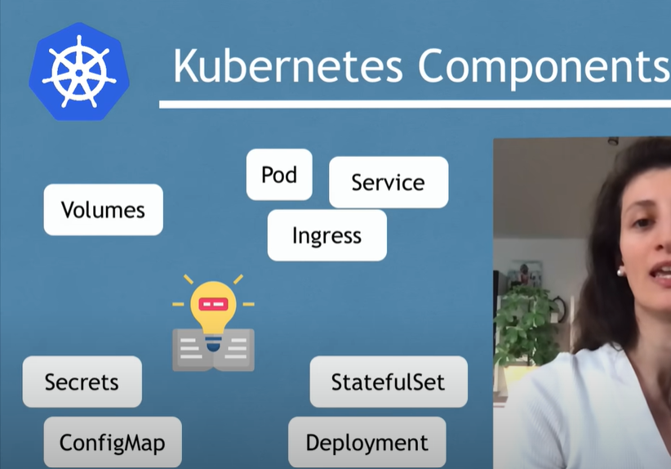

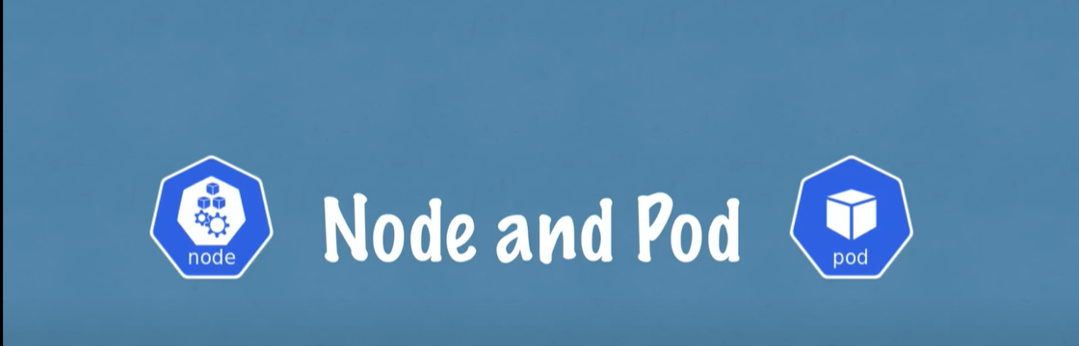

Node is a simple server, a physical or a virtual machine

Pod - Smallest unit of container

It is an abstraction over a container

Pod is usually meant to have ONLY one application container

K8 provides an virtual network. Which means each Pod gets its own IP address.

And not the container and pods communicate with each other using that IP address

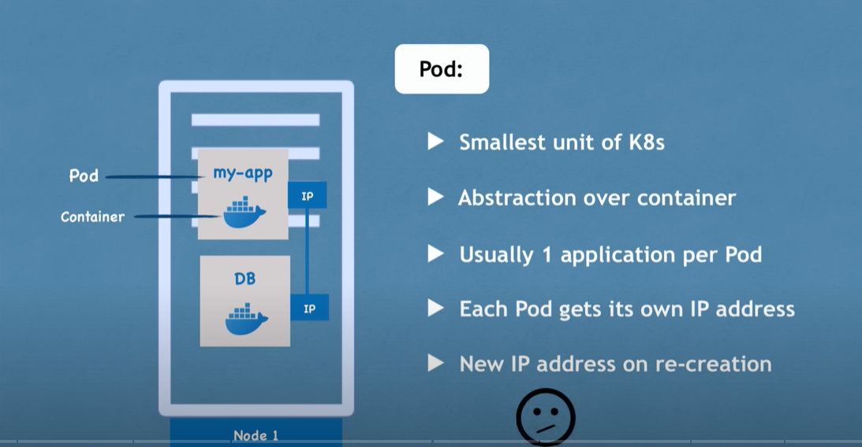

In above screenshot, my-app is communication with DB using IP address.

If DB is crashed, then new DB is replaced with new IP address. Which is incorrect

This case we use concept of SERVICES

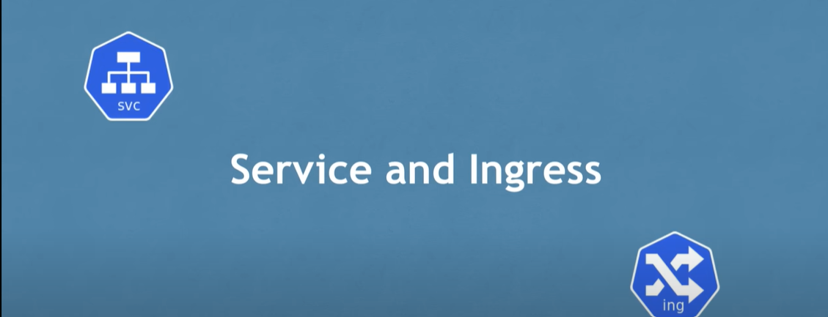

Service is a permanent IP address that can be attached to pod.

Pods communicate with each other using service.

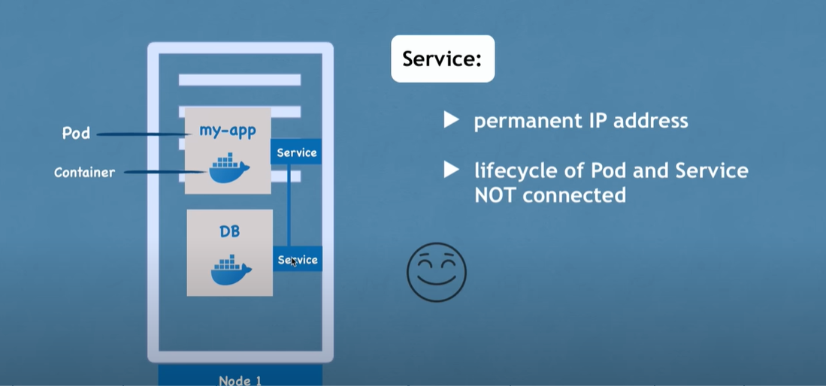

Now our application should be accessible from browser.

External service is a service that opens the communication from external sources.

In above image, only my-app should be allowed to accessed externally and not the DB

So for DB we use internal service

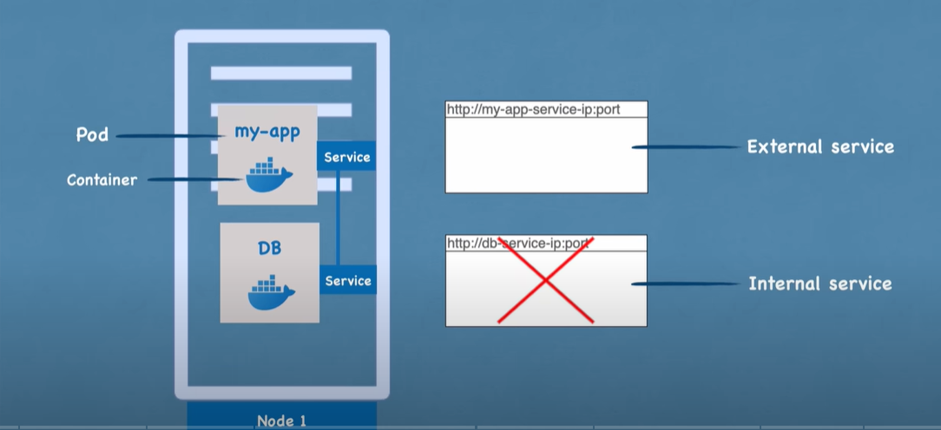

Ingress helps to give proper name to the url of our application

Request first comes to ingress and ingress maps the url and then forwards to service.

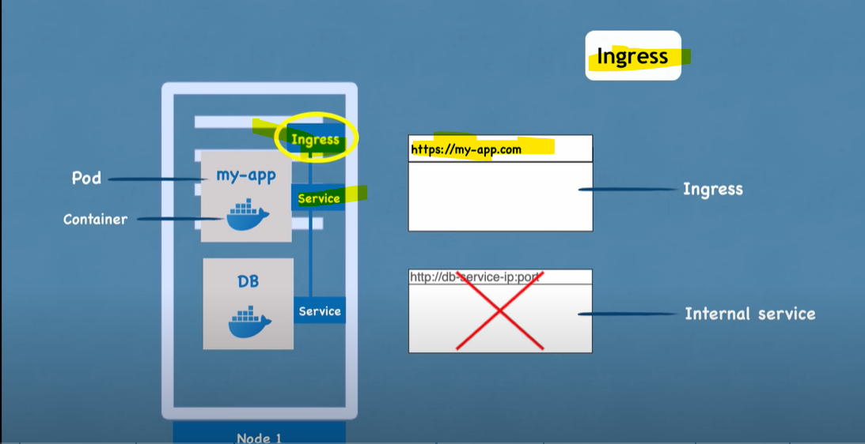

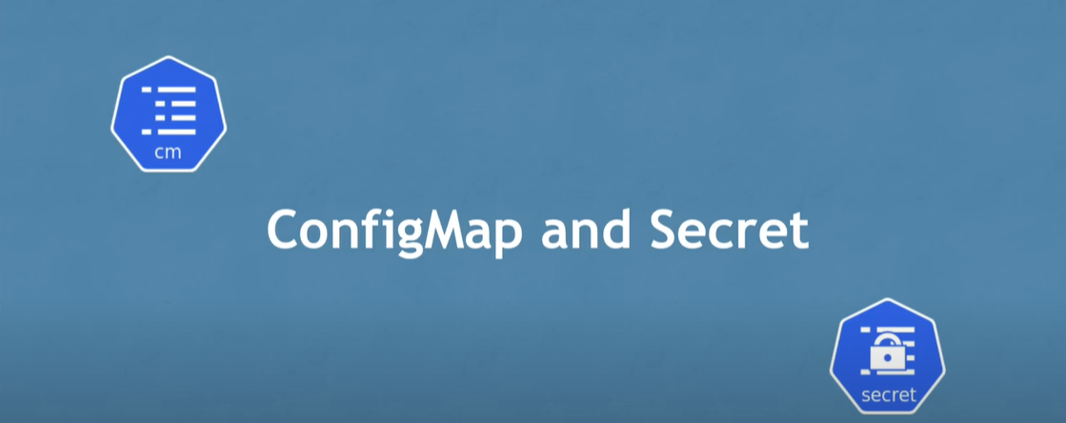

Config map is the external configuration of our application.

Ex: If we store mongo-DB url in my-app application-properties, then later if DB_url is changed, then

We need to update the new url in my-app properties, build the app and deploy.

To avoid these steps, we use config-map.

In kubernetes, we connect the config-map to the pod so that gets the data that config map contains

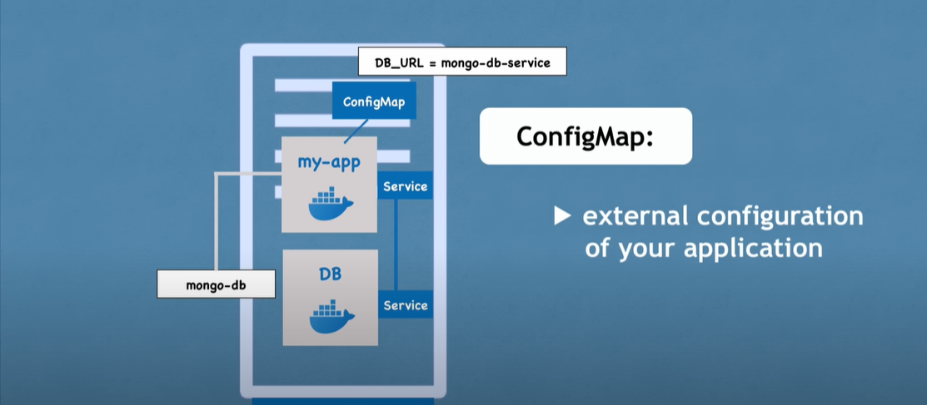

There can be other properties like DB username and password in properties file. It is NOT

recommended to add these details in config map.

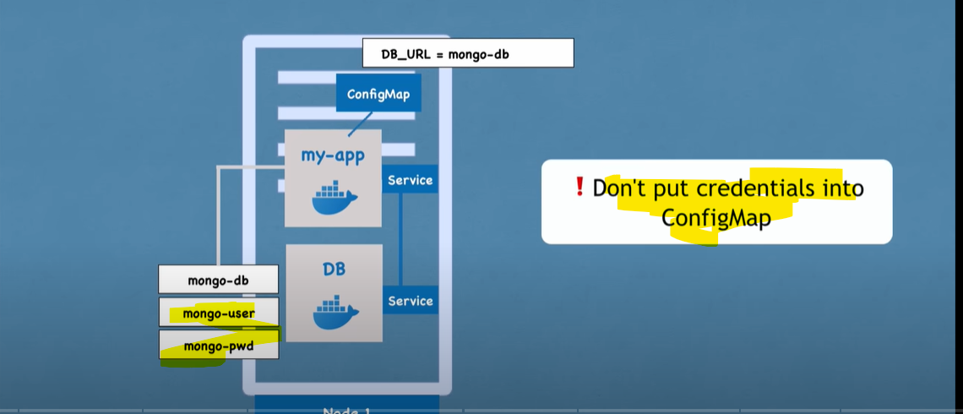

For confidential data like username and password, we need to use SECRET where data is stored in

Base-64 encoded format.

Just like config-map we need to connect Secret to the pod and pod gets the required data

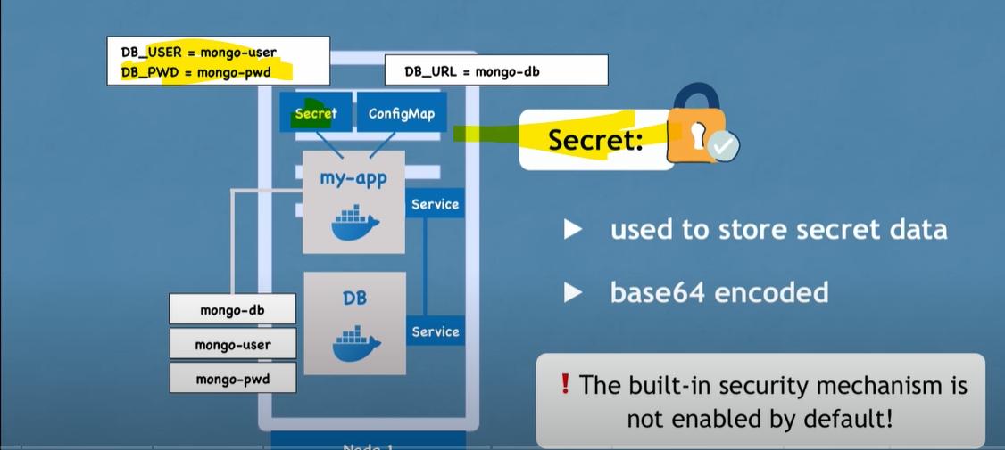

Using Environment variables or properties file, we can use the data present in config-map or Secret

inside our pod

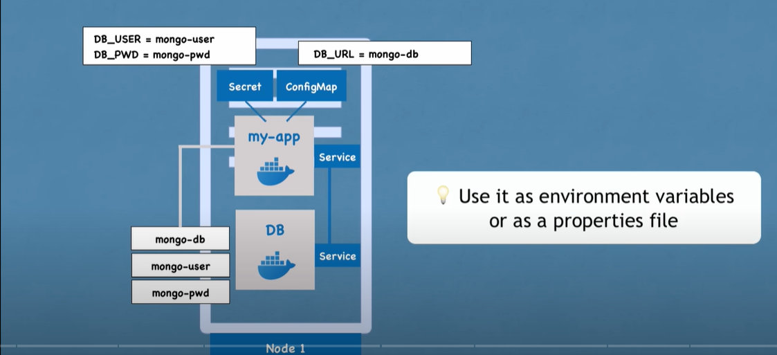

Below topics discussed so far

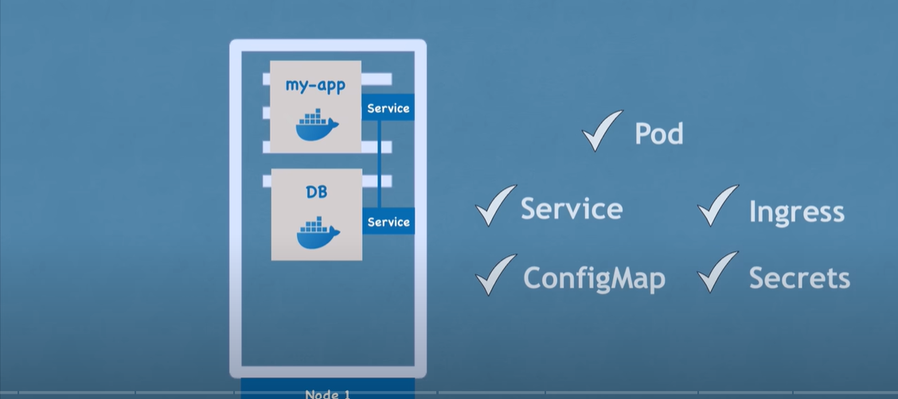



**How data storage works in Kubernetes ?**

If the pod containing the database is restarted , then the data would be lost and won't be persisted

Using Volumes we can persist the data in Kubernetes.

Volumes attach a physical storage on the hard drive to the pod. This storage could be on local machine

on the same server node where pod is running or can be remote storage(outside K8s cluster) i.e., cloud

So when the database or pod is restarted, the data would still be persisted.

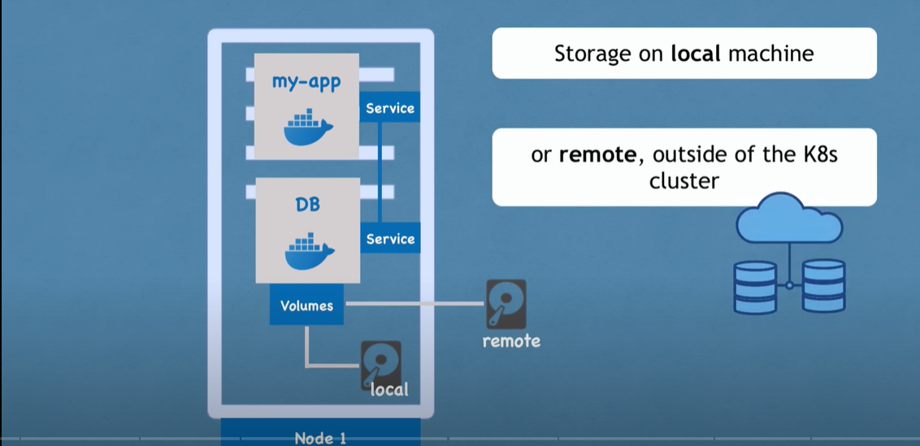

K8s doesn’t manage data persistence. We need configure the cluster in a way that data is persisted in

A storage which is plugged in to K8s cluster.

Note: Storage can be external hard drive

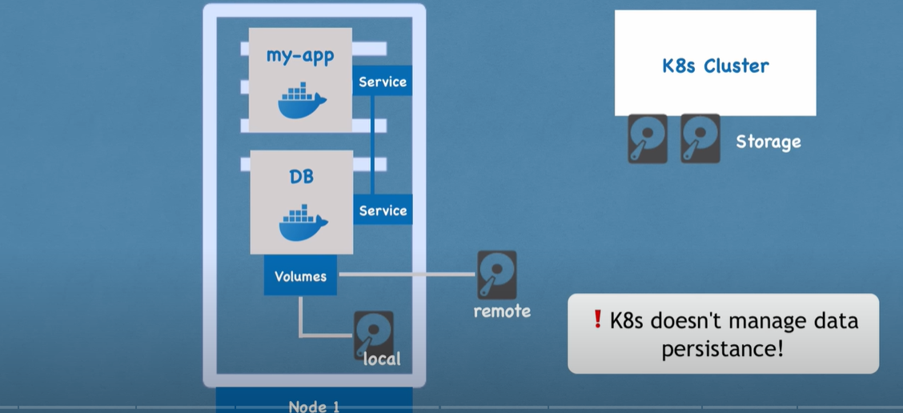

Let us consider a scenario where my-app is down. Either it was crashed or restarted and there is

Downtime where user can't reach the application.

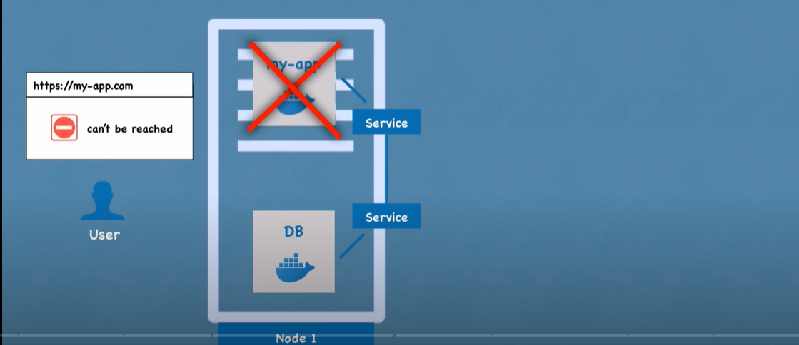

To handle these kind of scenarios, replicate the nodes/servers.

These nodes are connected to the SAME SERVICE.

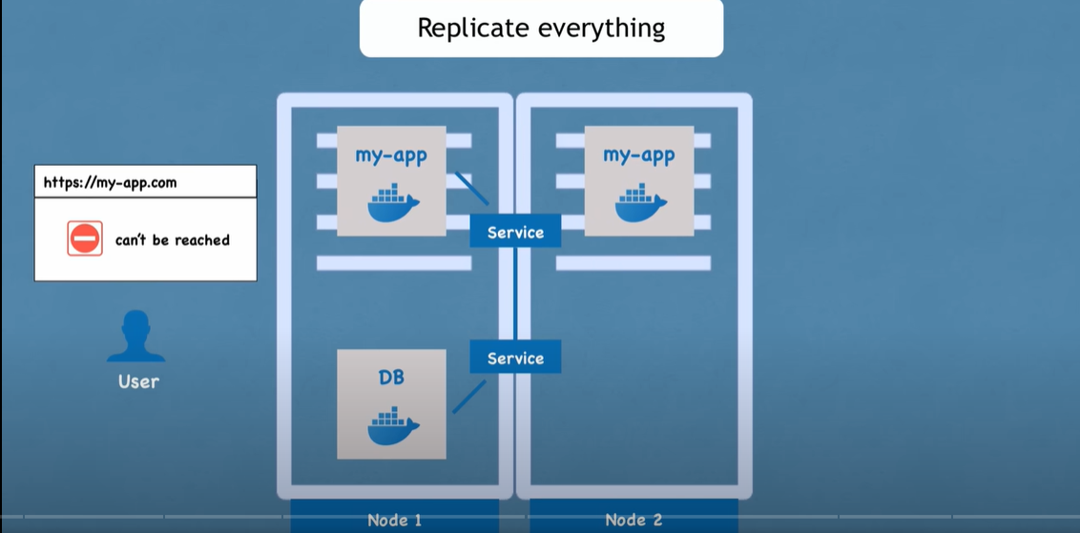

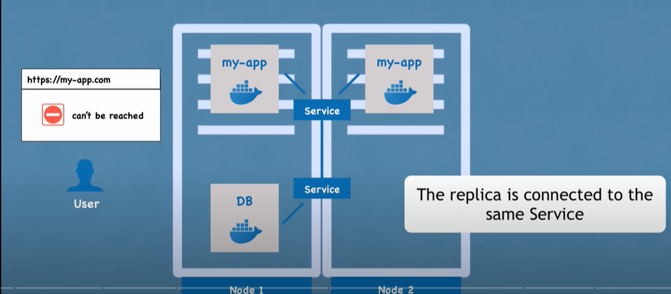

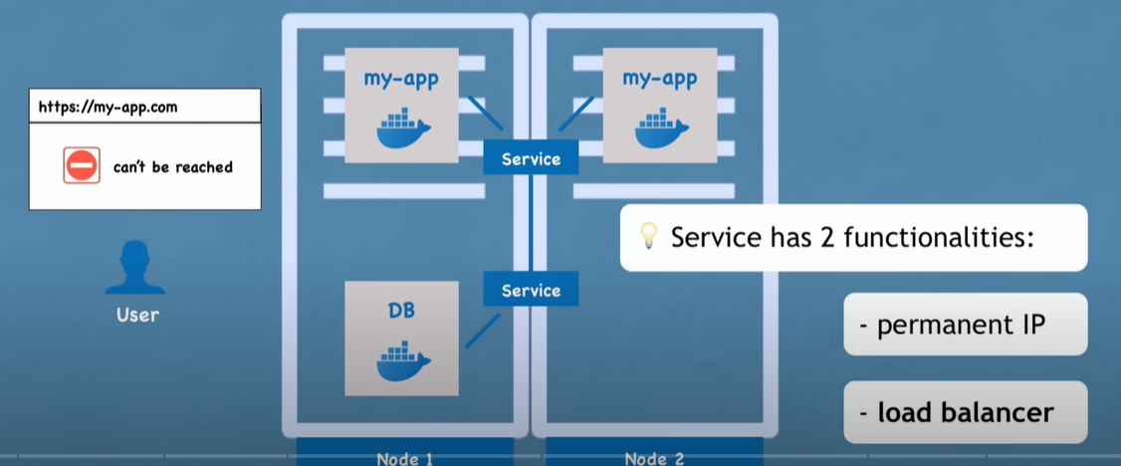

Actually we don’t create a new replica pod. We define blue print for pods and mention the replicas.

That component or blueprint is called Deployment . Deployment is another component of k8s

Deployment is a blue print for my-app pods.

Here we can scale up or scale down the number of replicas.

Deployment is another abstraction on top of pods.

In practice, developers mainly work with Deployment(blueprint) and not on pods/containers

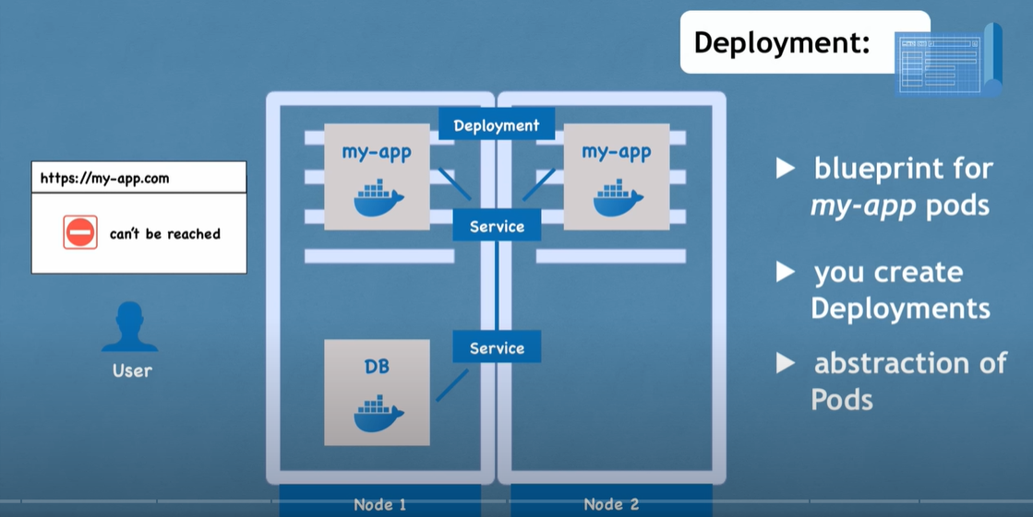

If one application is down , then the request will route to the replica application.

However we can't replicate Databases via Deployment.

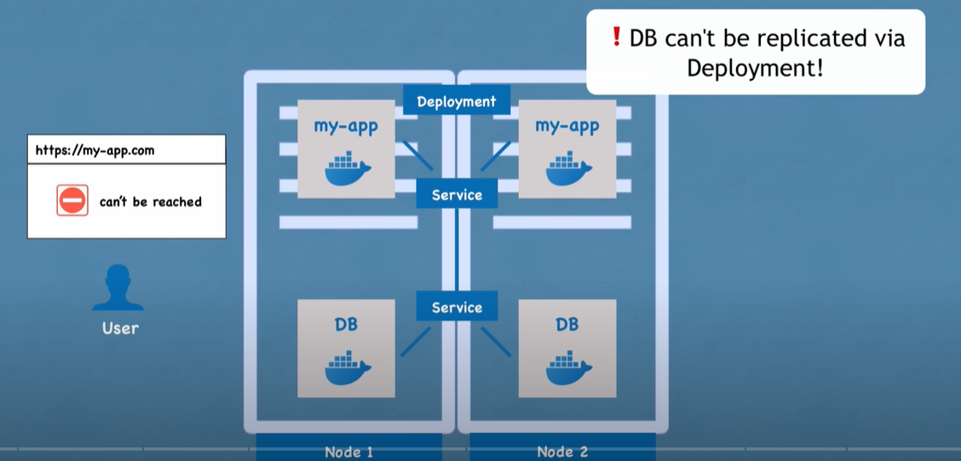

To avoid data inconsistences , we cant replicate Databases, we will not be sure which pod will read or

Write data from which database.

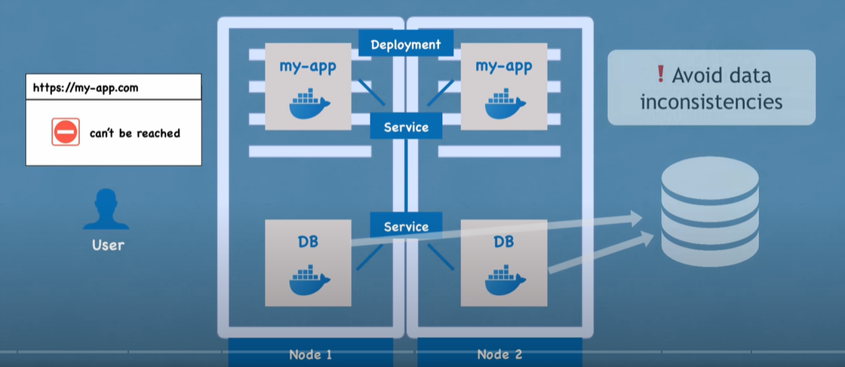

To address these scenarios related to databases, we have one more component in k8s calles

**StatefulSet**

So Stateful apps like MongoDB, mySQL etc should be created using Stateful sets and not via Deployments

StatefulSets takes care of replicating the pods, scale up, scale down and make sure data base reads and

Writes are synchronized so no database inconsistencies are occurred.

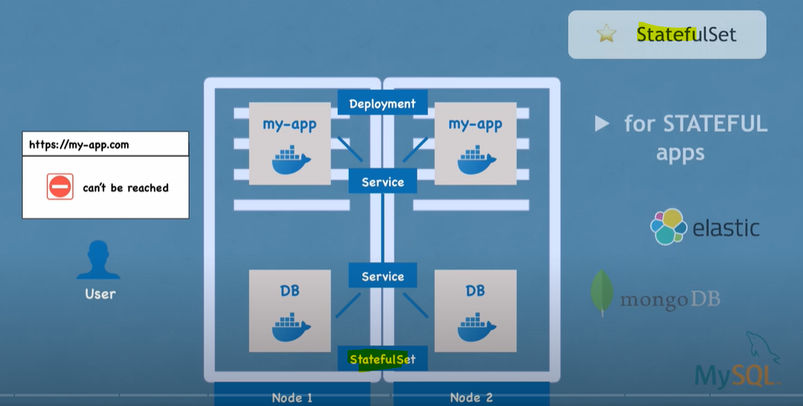

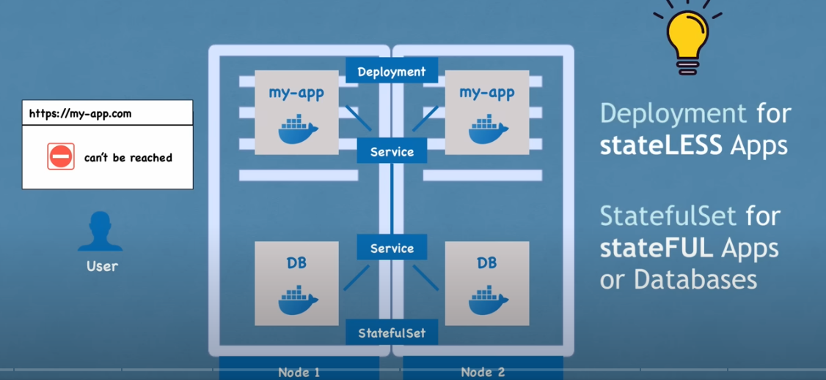

However deploying Databases with StatefulSets is not easy

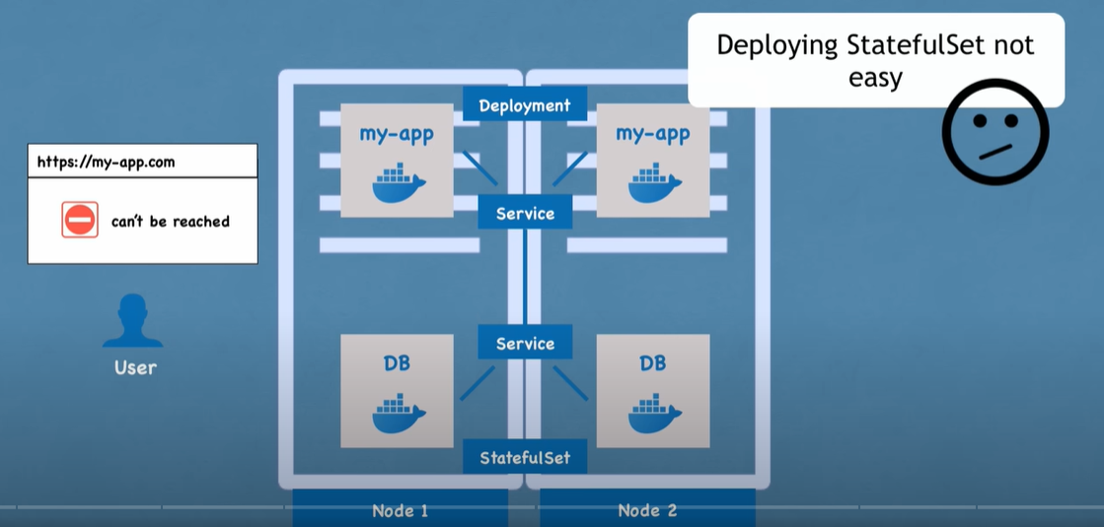

So it’s a good practice to host the databased outside the k8s cluster

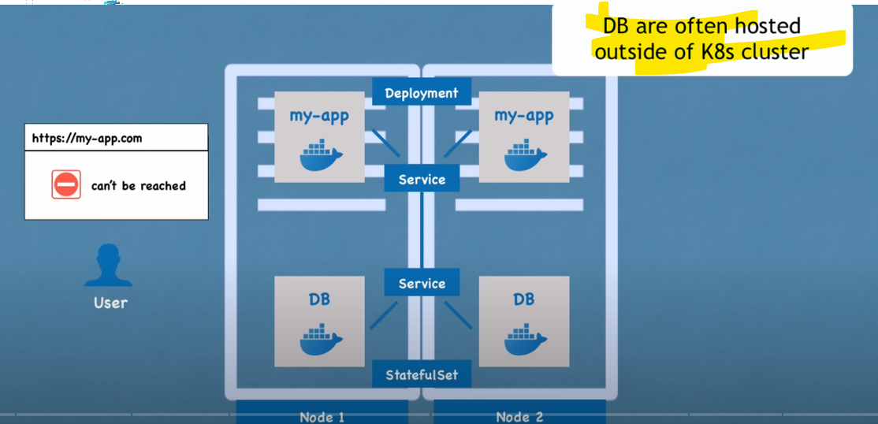

Recap

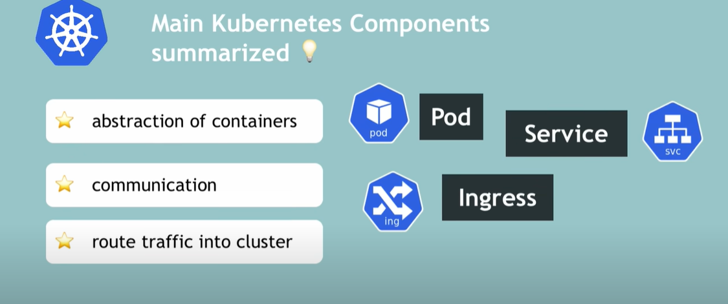

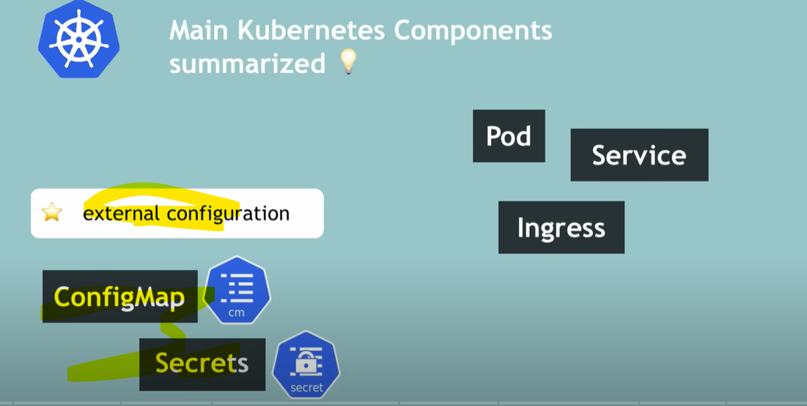

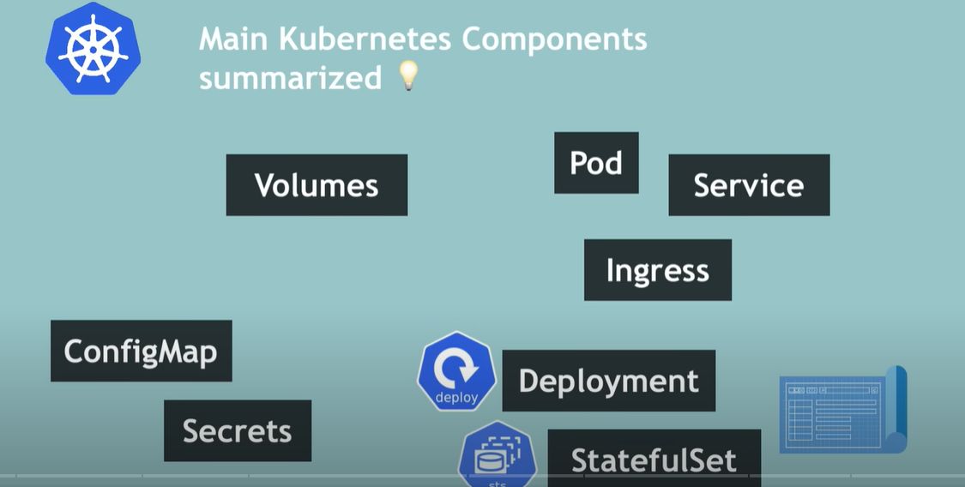

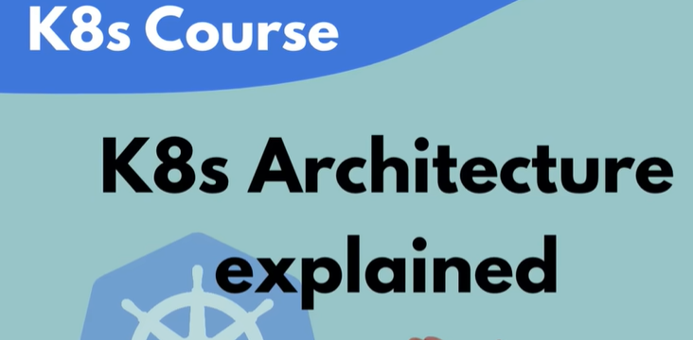

K8s operates on two types of nodes.

1. Master
2. Slave



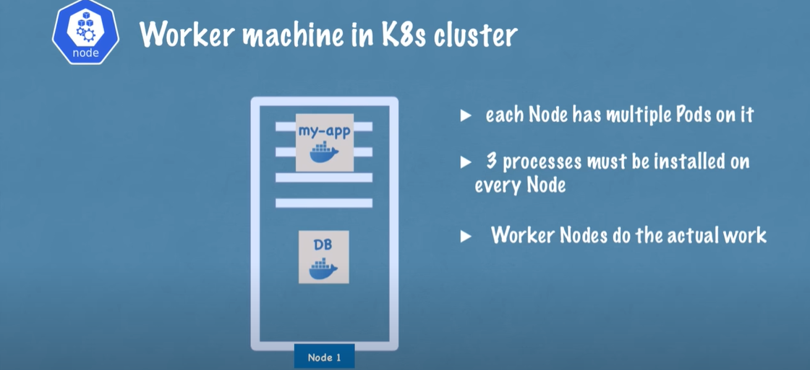

3 processes must be installed on every node:

1st process that needs to run on every node is the 'Container runtime' (ex: docker)

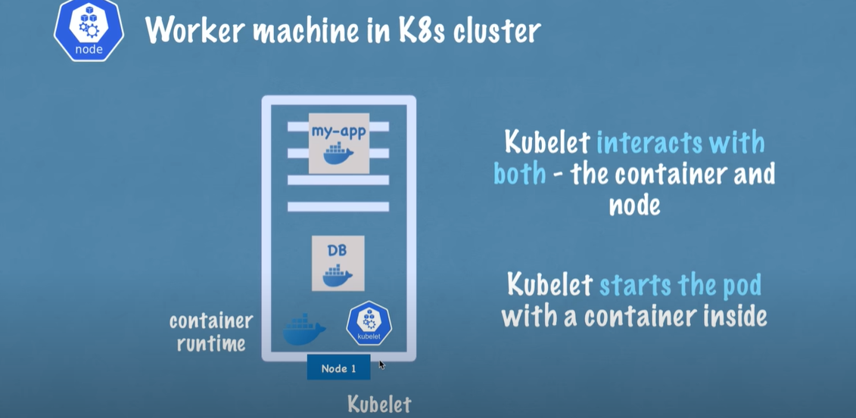

2ns is the process that schedules the pods and the containers underneath is the Kublet.

Kublet starts the pod inside a container and helps in assigning resources from the node to the container

Like CPU, RAM and storage resources.

K8s cluster has multiple nodes each containing container-runtime and Kublets. And communication between

the nodes happens via Services. Services act as load balancer, which catches the request and directs to the pod

Or the app like database

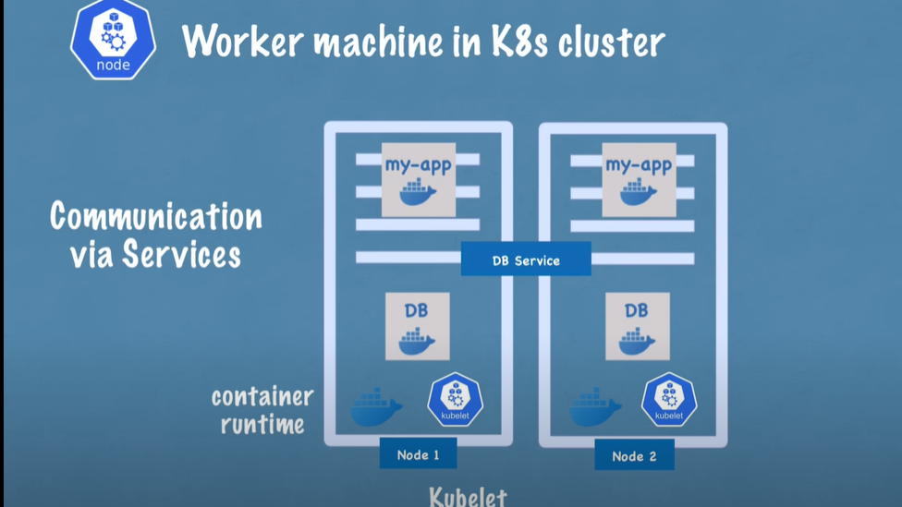

3rd process is that is responsible for forwarding request from Services to pods is 'Kube proxy'.

This should also be installed on every node.

Kube proxy has intelligent forwarding logic inside that makes sure comm happens in a performant way.

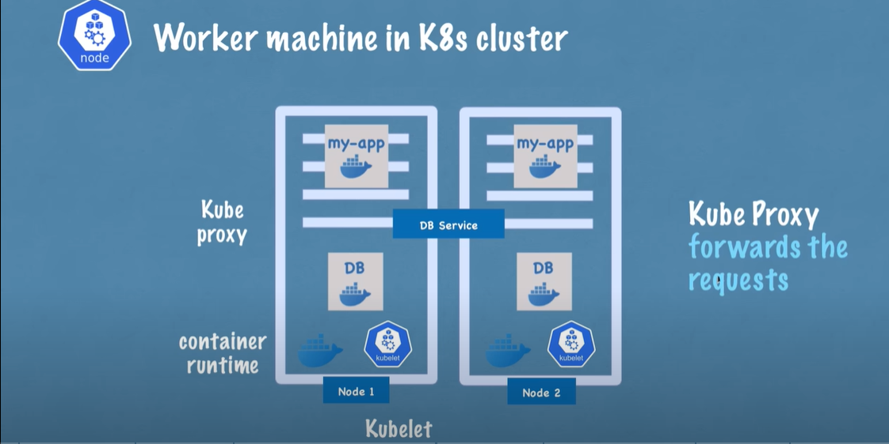

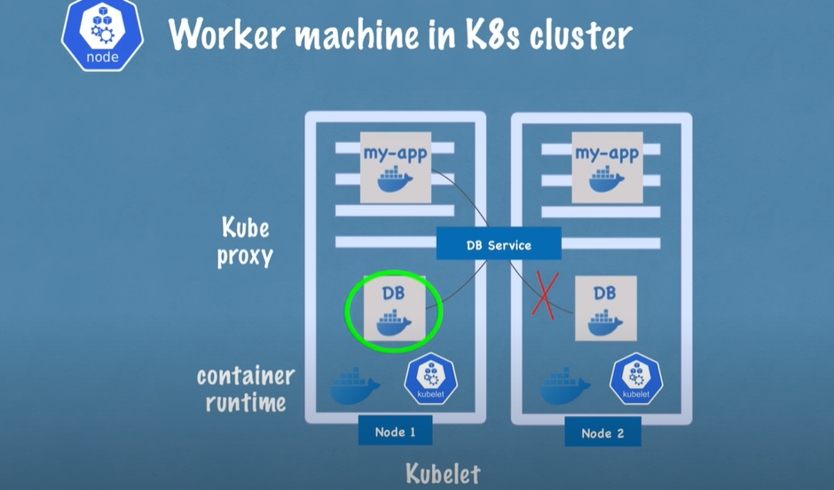

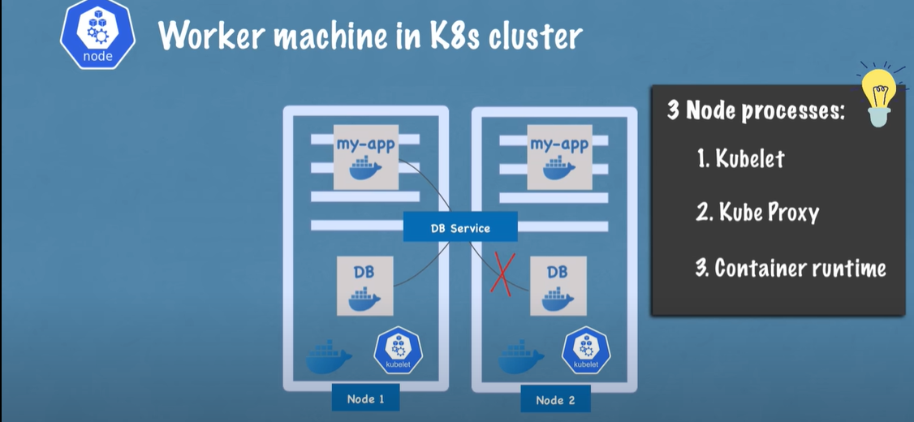

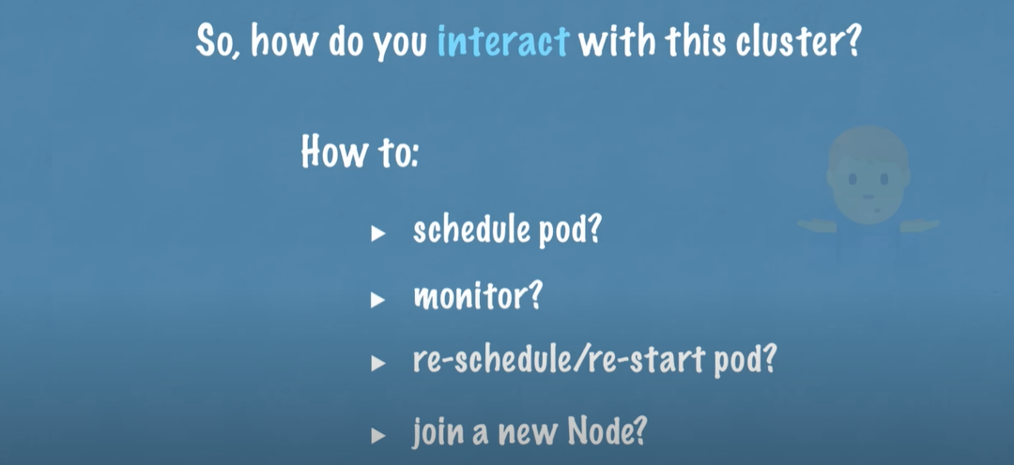

How to scheulde pod ?

How to monitor pod ?

How to restart pod ?

All the above like managing pod, scheduling pod , restarting pod are done by **Master Nodes**

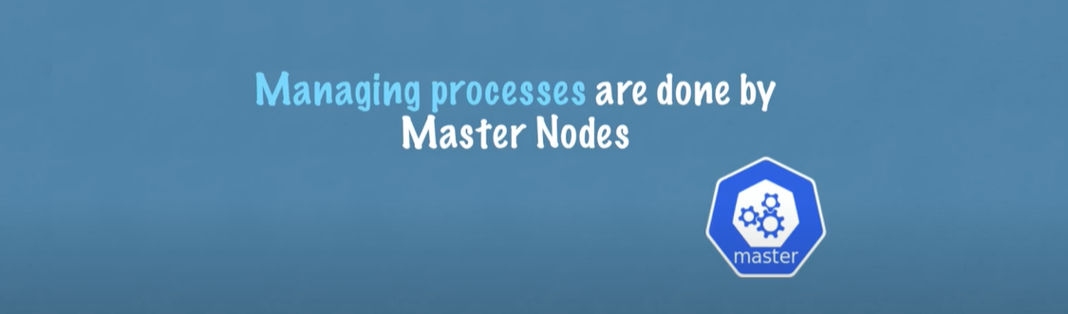

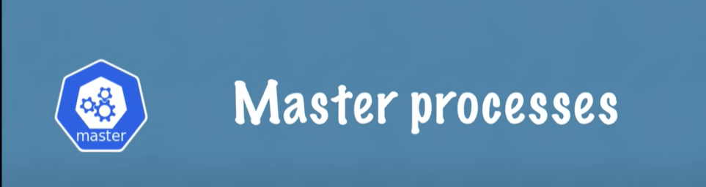

Master servers/nodes have 4 different processes running inside that control the cluster state and the worker

nodes as well

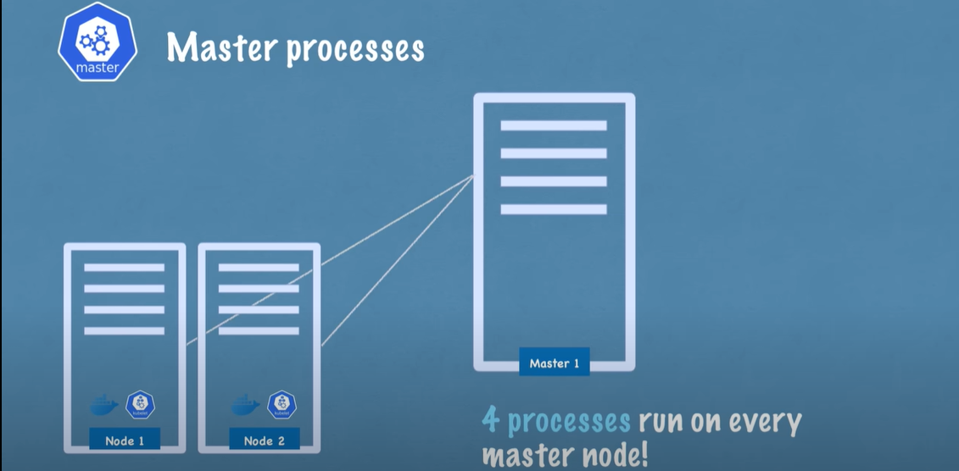

**1st process is API Server**.

API server is like a cluster gateway, which gets the initial request of any updates into the cluster

It also acts as a gate keeper for authentication

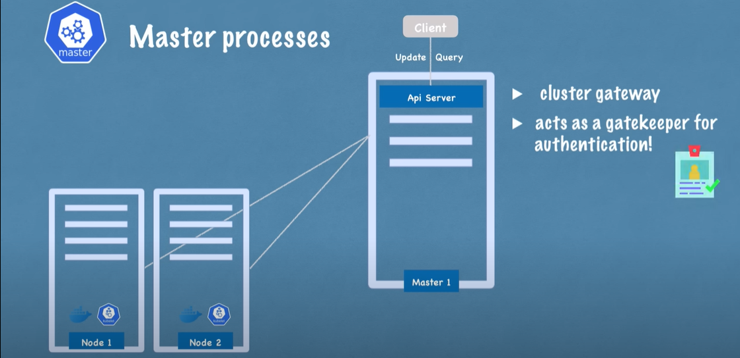

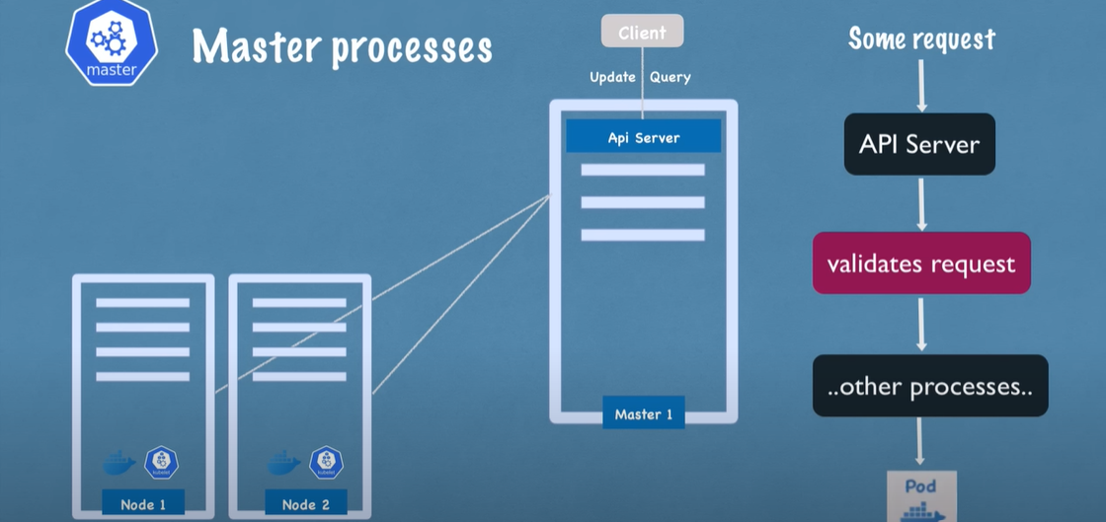

**2nd Master process is the Scheduler**

Request comes to API server first. After API server validated the request , it then passes it to Scheduler to start

application pod in one of the worker nodes.

Instead of randomly assigning the node, Scheduler has intelligent way of deciding on which specific worker node

the next pod will be scheduled.

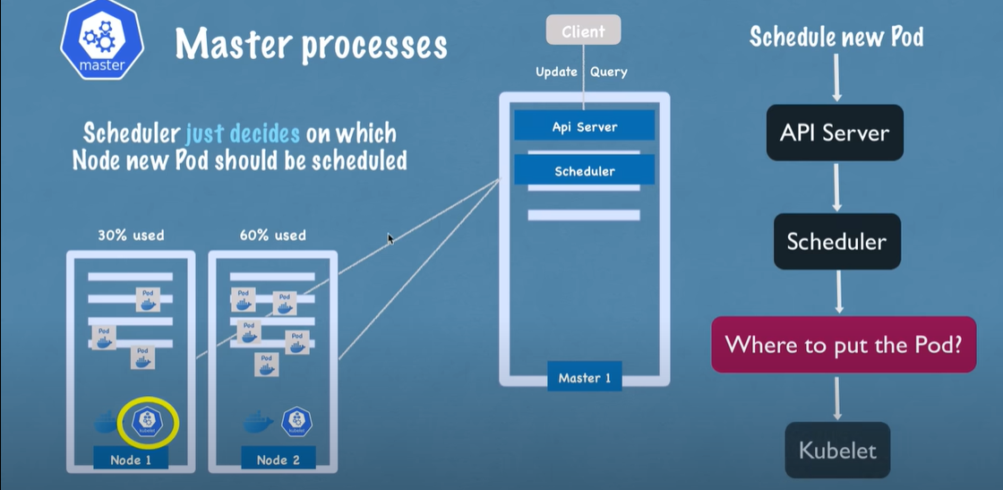

Scheduler Just decides on which Node new pod should be scheduled, however the process that actually starts

the container is the Kublet.

**3rd process is the 'Controller Manager'**

If any pod is down or crashed on any node. There must be way to detect these crashes and reschedule those

Pods ASAP. So Controller Manager helps to detect the cluster state changes(ex: crashing of pods).

Controller Manager sends request to Scheduler to reschedule the dead pods and from there on Scheduler continues

its process by calculating resources and makes request to corresponding Kublets on the worker node to restart pod

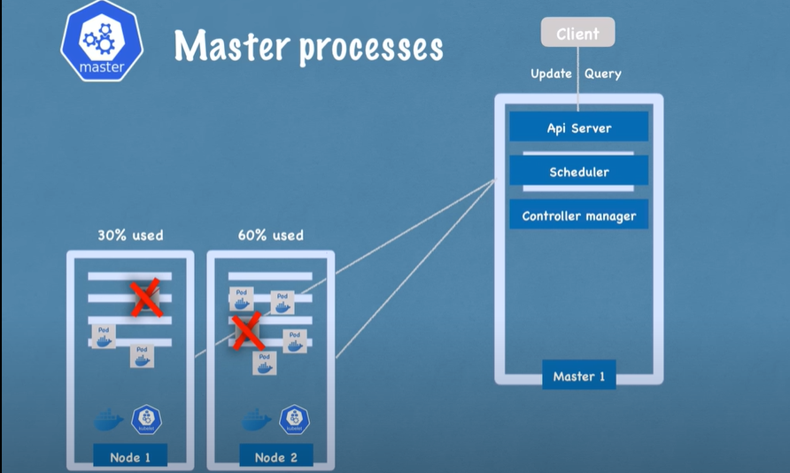

**4th Master process is 'etcd'**

It is a key-value store of a cluster state.

etcd can be considered as a cluster brain. Example, if any new pod gets added, or any pod crashes…all these changes

are updated in key-value store of etcd.

How Scheduler knows what resources are available on worker node ?

How does Controller Manager knows that Cluster state has changed ? Ex; pods crashed or Kublet restarted pod

Query request to API server regarding cluster health or application deployment state ? All these state information

from where does API server gets ?

So all these information is stored in and provided by etcd, the cluster Brain.

However Actual application data is not stored in etcd.

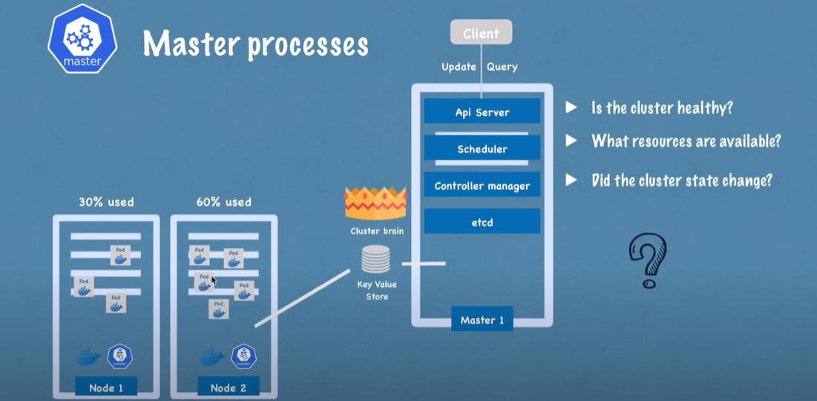

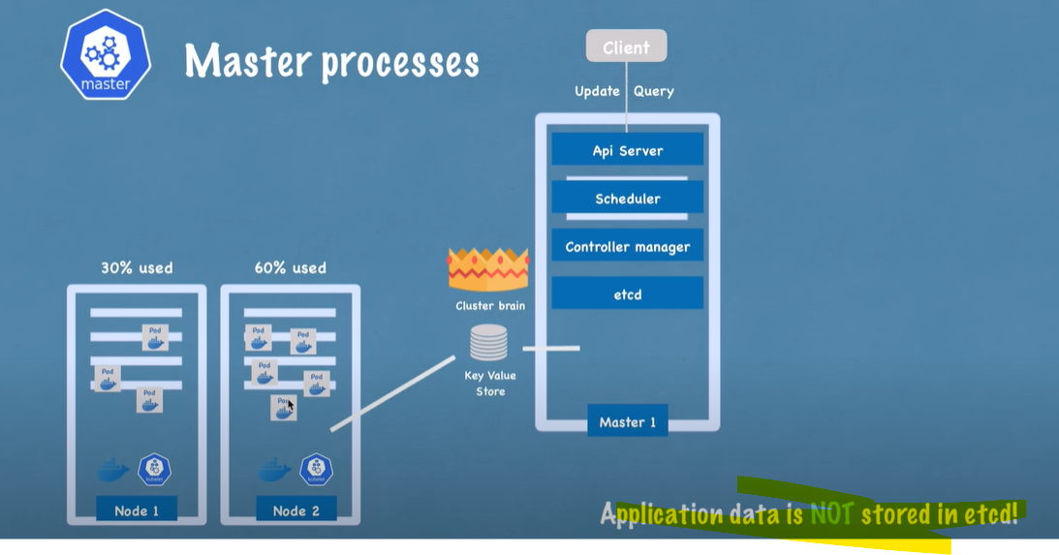

In practice, K8s clusters are made up of Multiple Masters

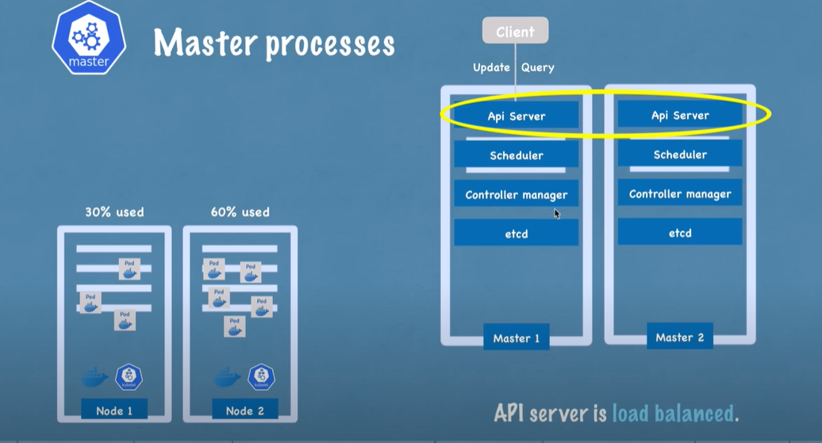

Etcd forms a distributed storage across all master nodes

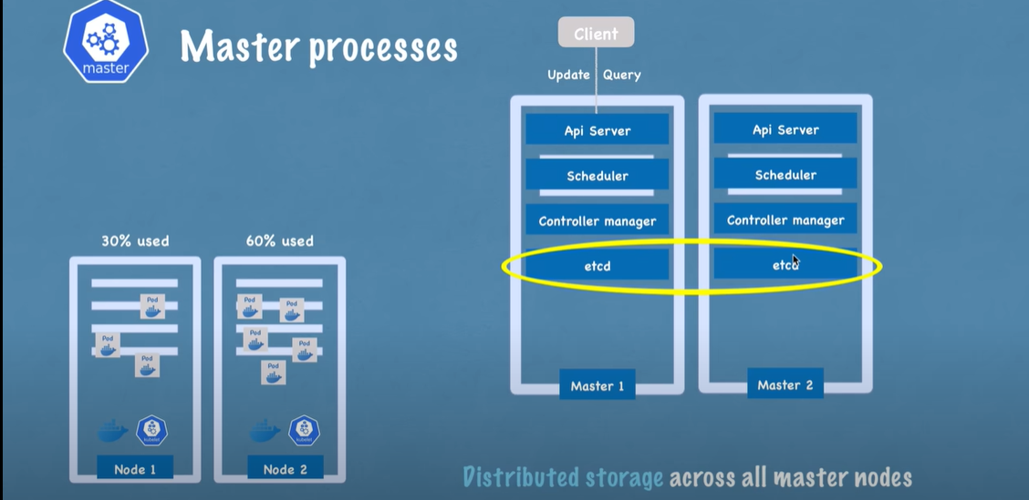



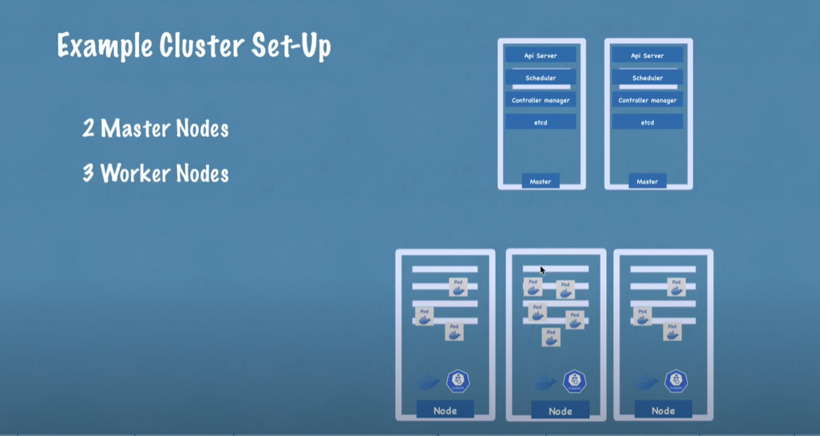

Master nodes requires less resources (CPU| RAM | Storage),

Worker nodes require more resources (CPU| RAM | Storage),

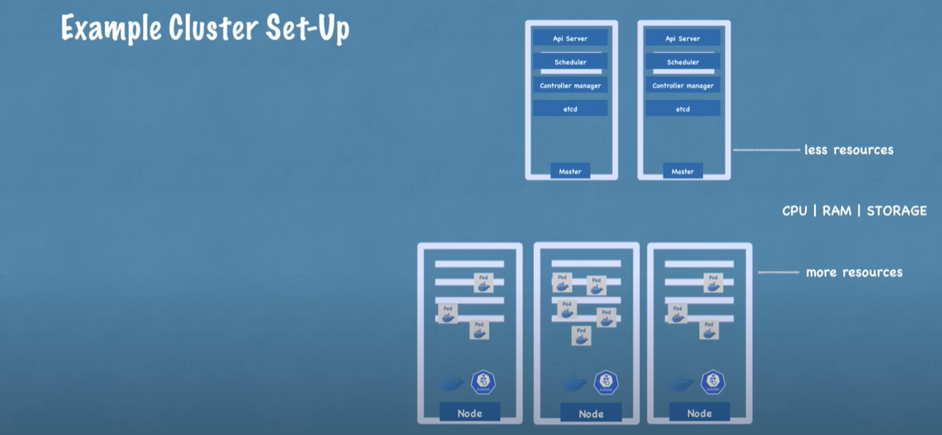

If the application demand increases, we may add more master nodes and worker nodes.

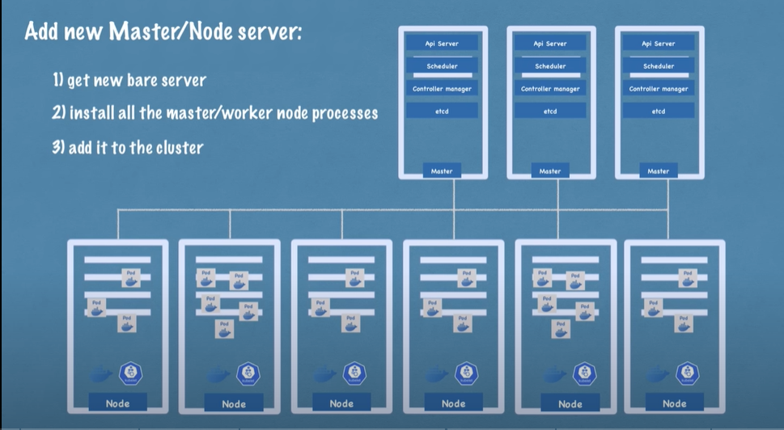

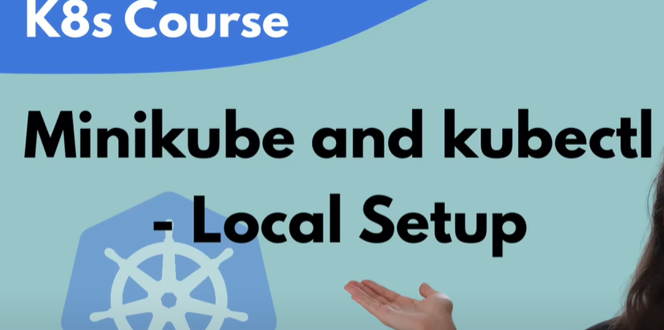

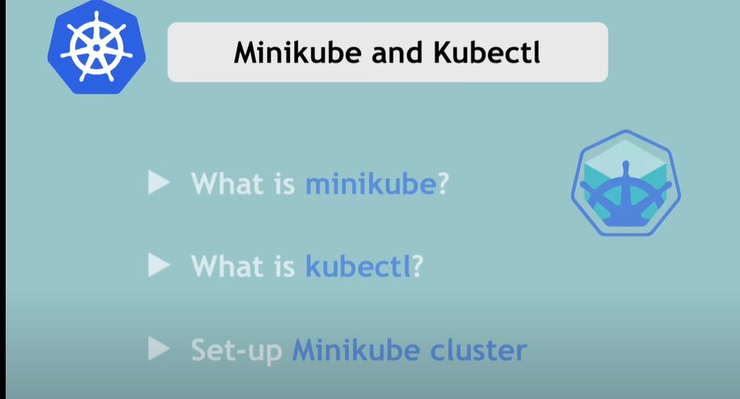



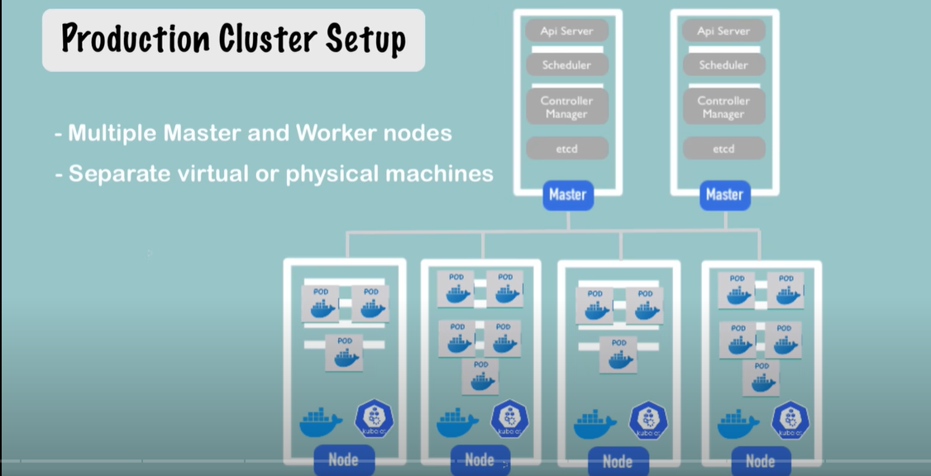

Production cluster has multiple master and worker nodes.

To test in local, it is difficult to have this setup in our local machine as it requires multiple CPUs storage etc..

To test this kind of environment in local we have a open source tool called **MiniKube**.

In MiniKube, we have one cluster where Master and Node processes run on same machine. And this node will

have Docker container pre installed

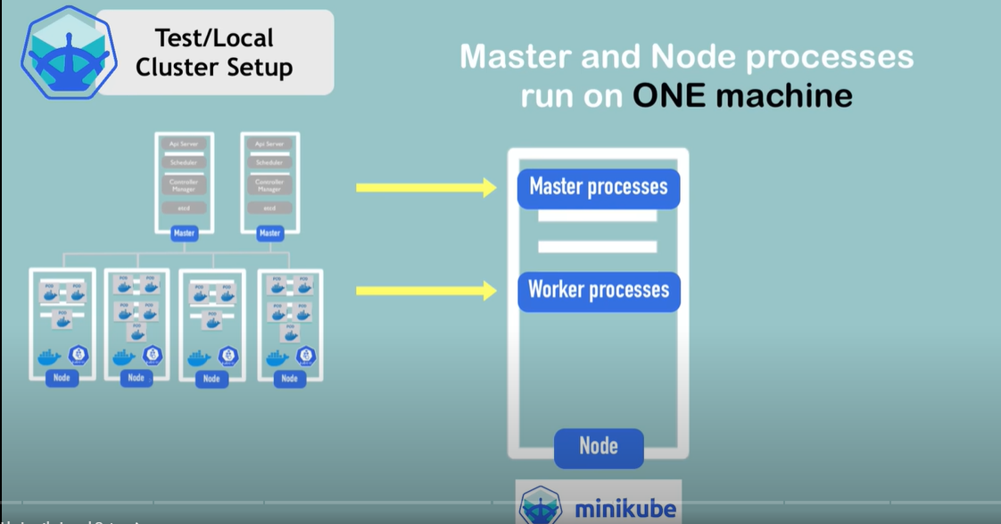

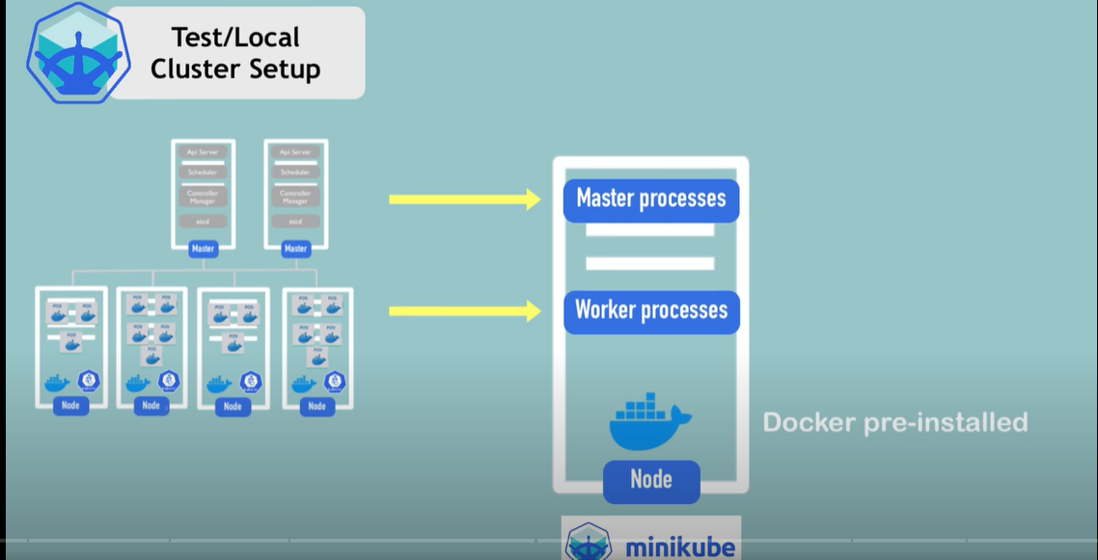

This runs in our local machine/laptop through a Virtual box

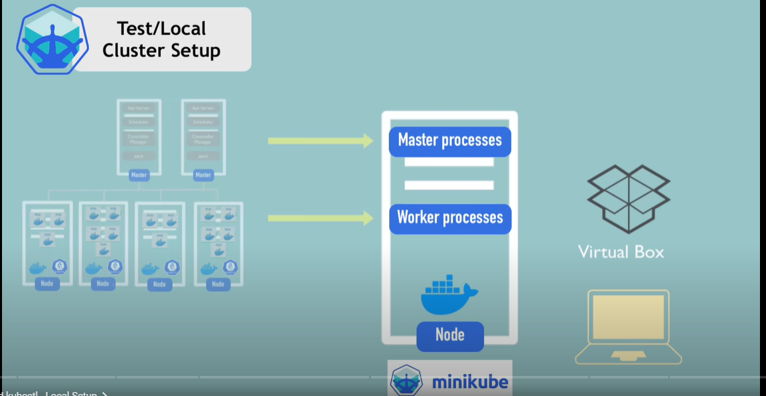

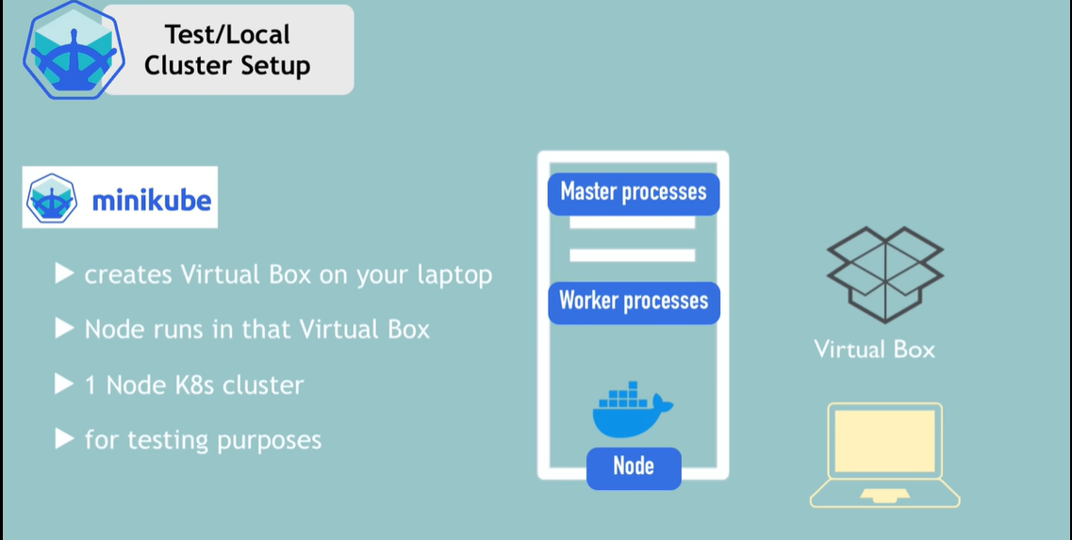

With MiniKube we will set up the cluster/nodes etc.

Now we need a way to interact with the cluster. MiniKube will use **kubectl** to for this communication



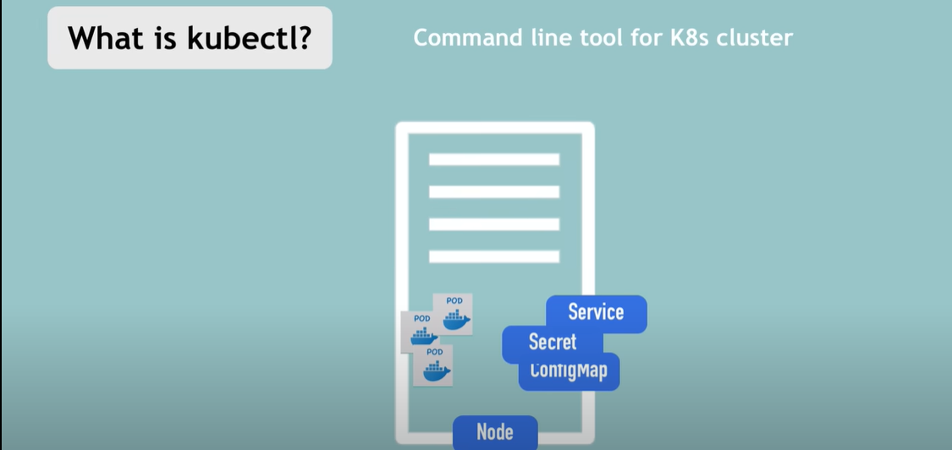

Master process connects to Api Sever which is the entry point for worker node.

The way to talk to API server can be from any client line UI, k8s API or from command line tool which is kubectl.

Kubectl is the most powerful of all the 3 clients

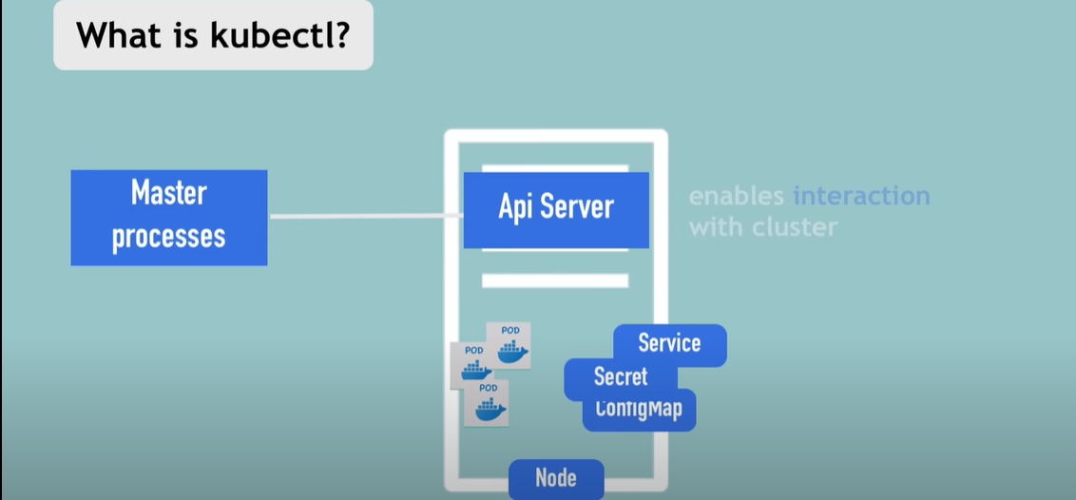

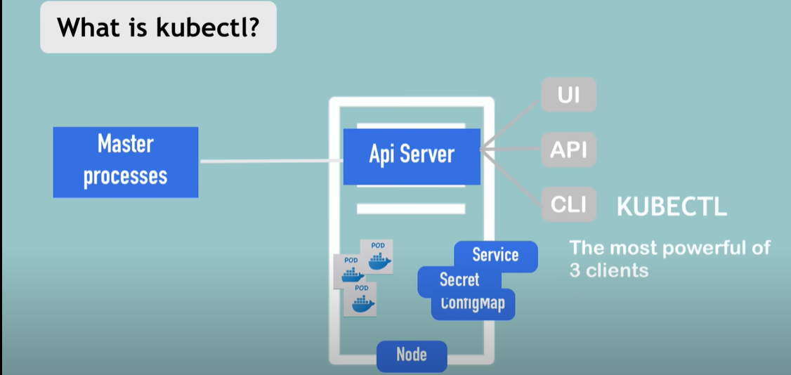

Once kubectl issues commands to API server create/delete components, pod,services etc, the worker processes will make it

happen by executing those commands

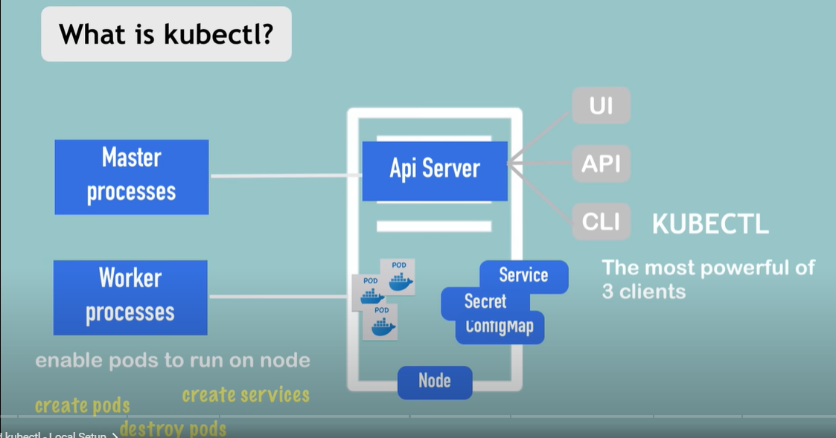

Kubectl can be used to interact with Minikube cluster, cloud cluster and any kind of k8s cluster

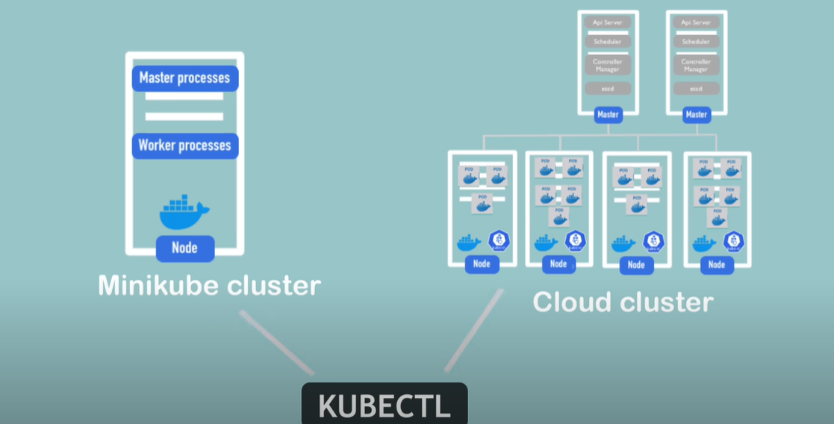

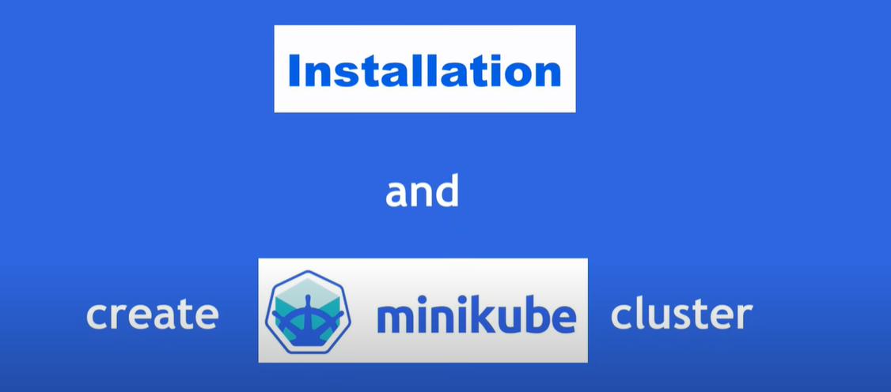

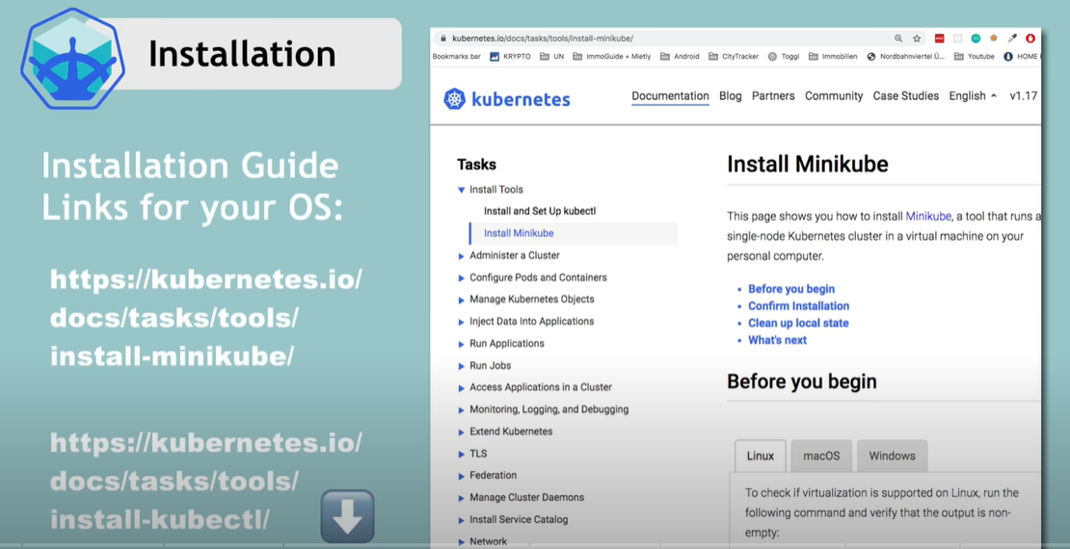

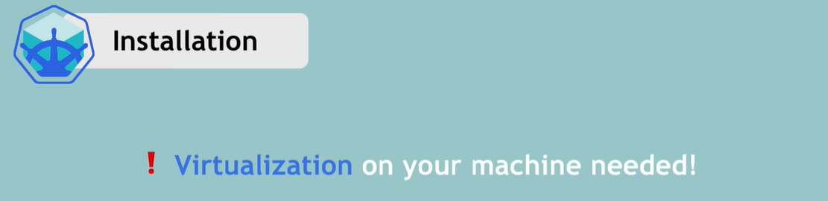

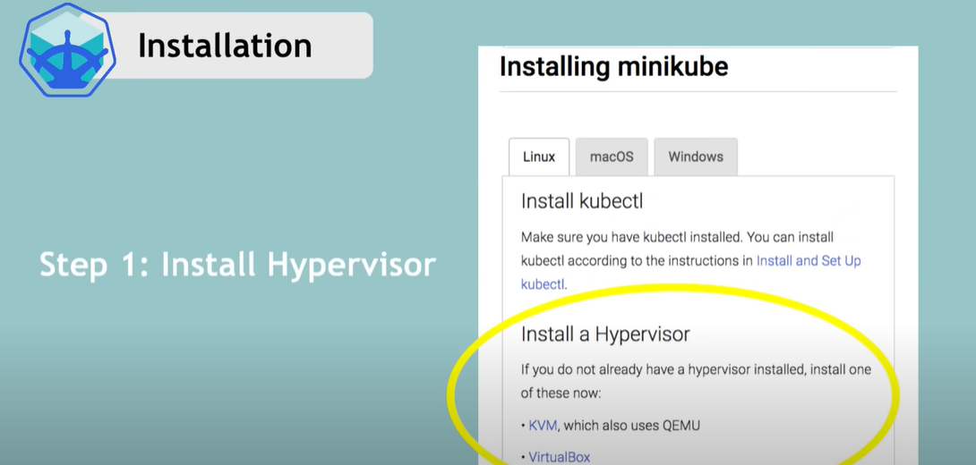

Below steps are for mac

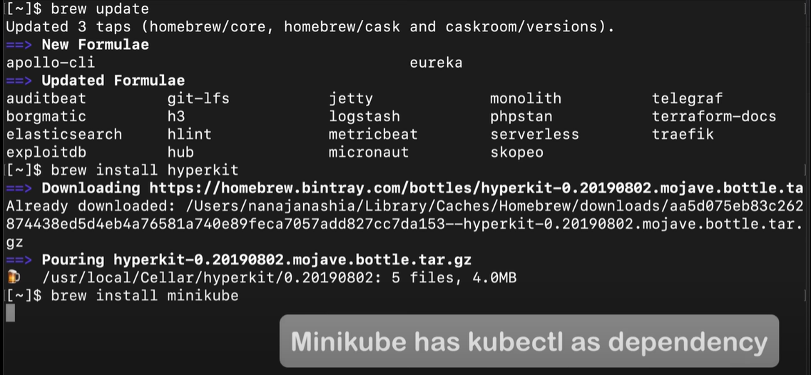

MiniKube has kubectl as dependency. So no separate installation for kubectl is required

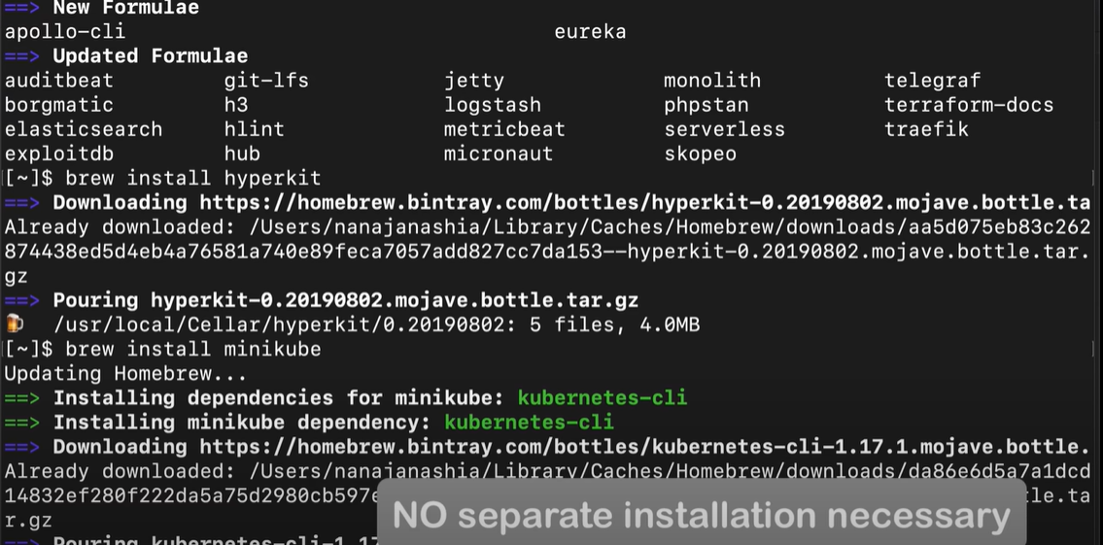

Command to create and start the cluster:

**minikube start --vm-driver=<hypervisor name>**

This is where hypervisor installed comes in picture

And also Docker runtime is pre-installed with minikube.

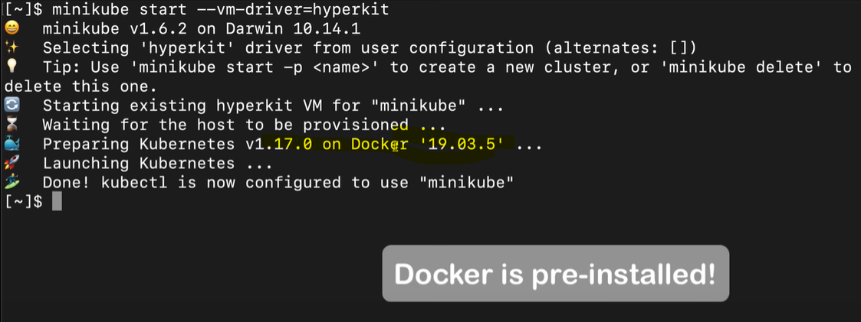

Command to get status of node

**kubectl get nodes**

Command to get minikube status

**minikube status**

Command to get kubectl version

**kubectl version**

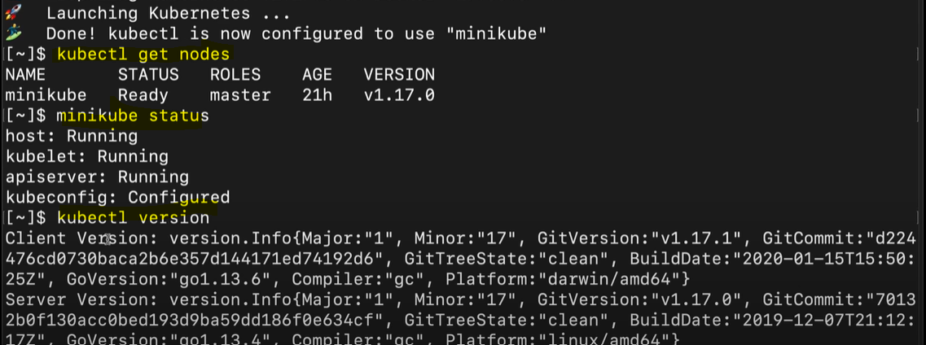

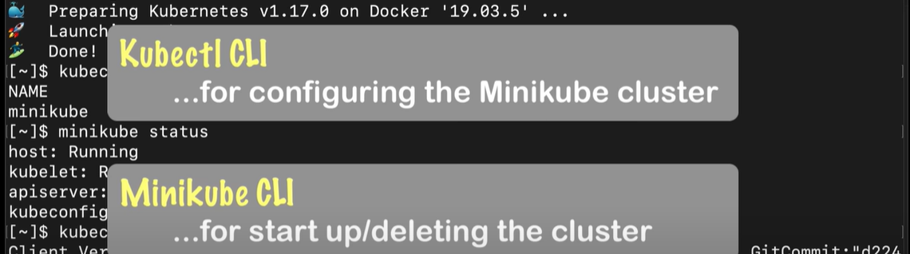

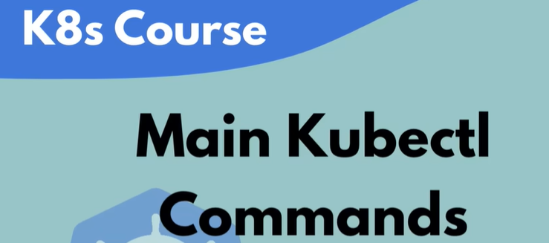

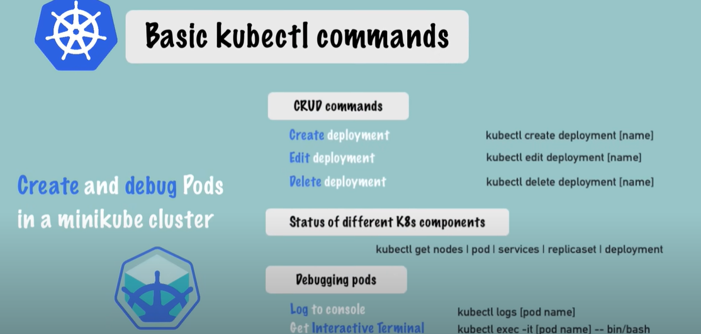

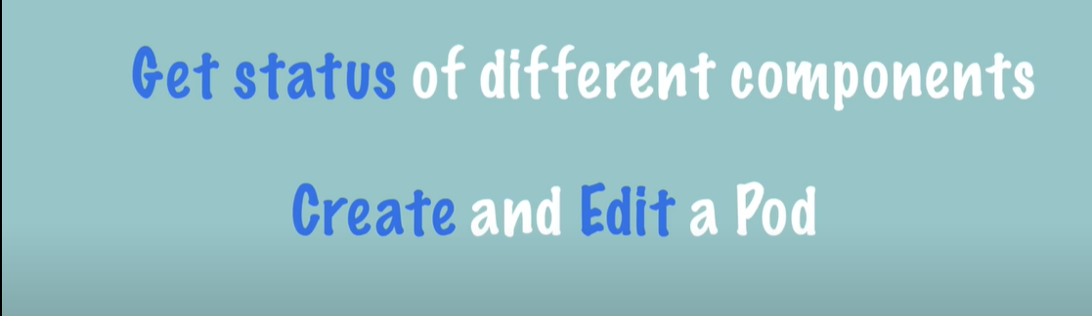

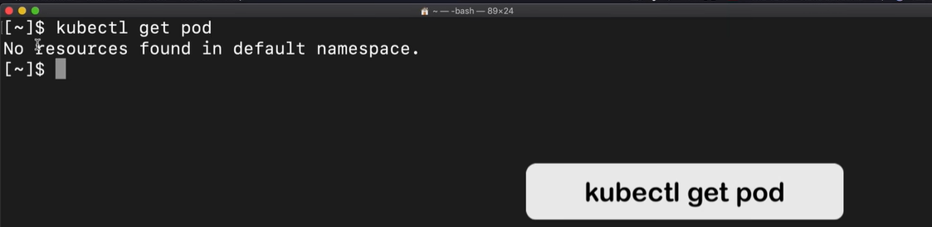

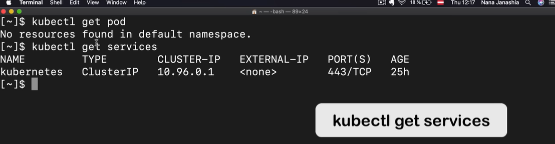

Command to create pod.

There is an abstraction layer over pod called Deployment. So we cannot create pod directly, instead we create

deployment

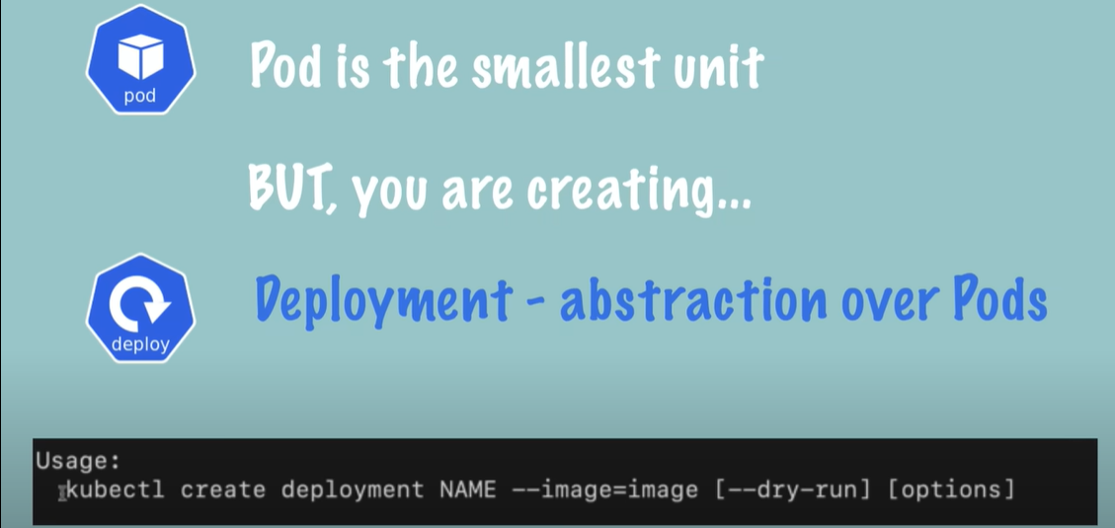

Example to create nginx deployment and check its status

Here --image=ngnix will download the docker image of ngnix

The below command will create only one replica of the pod.

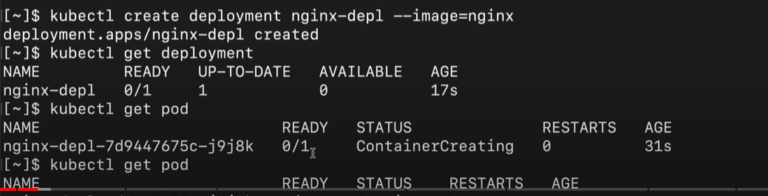

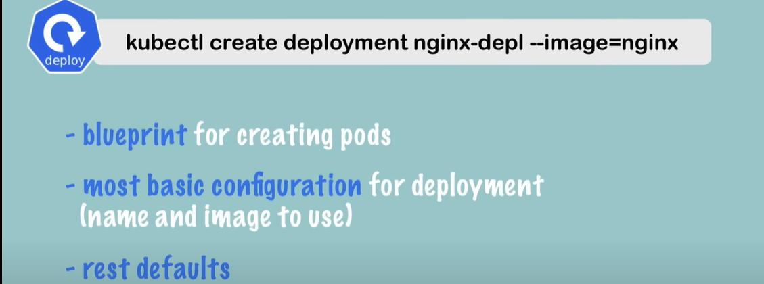

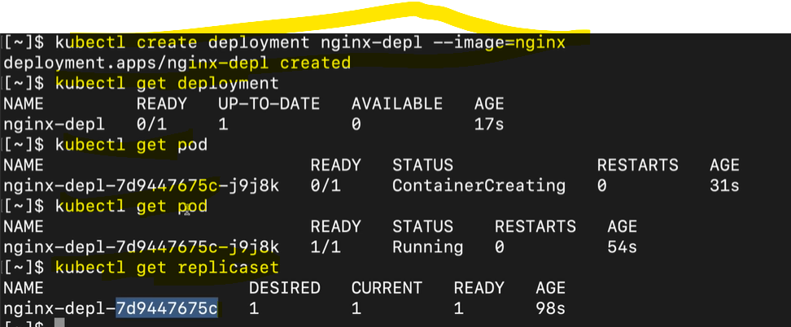

Layers of Abstraction

Deployment manages a ReplicaSet

ReplicaSet manages all the replicas of the pod

Pod is an abstraction of a container

Everything below the deployment should be automatically managed by the Kuberenetes

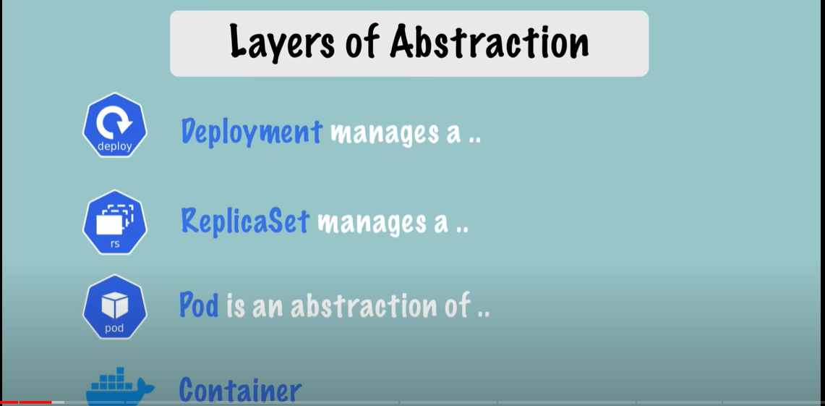

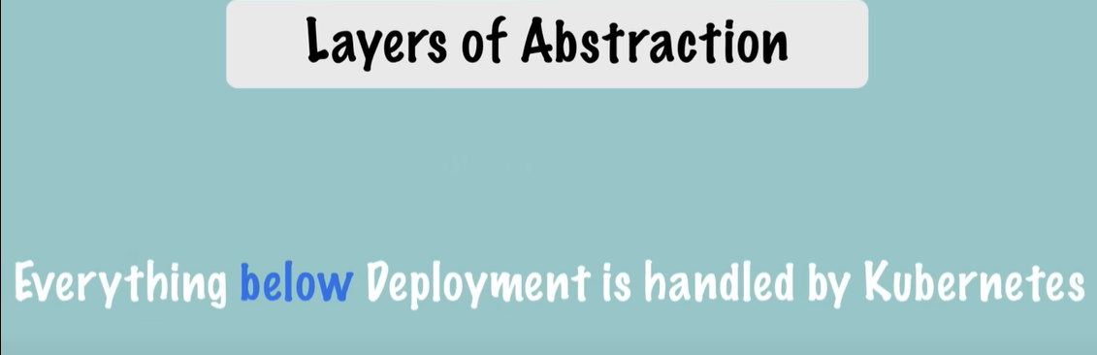

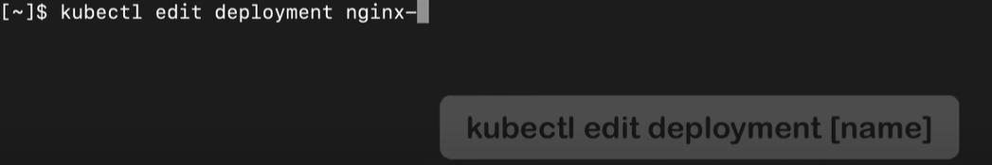

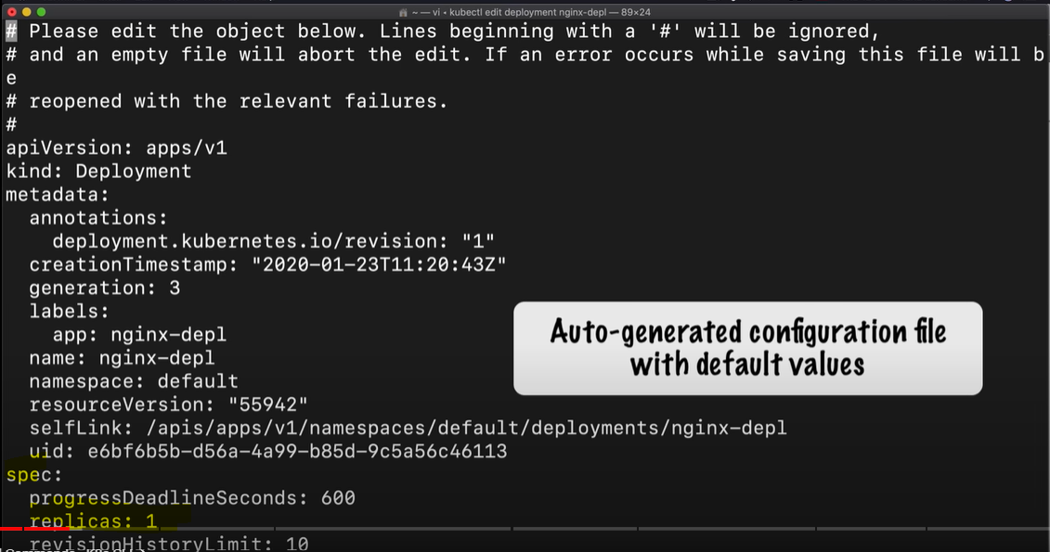

Edit the config file, save it and get status of the pod. Old pod will terminate and new pod starts.

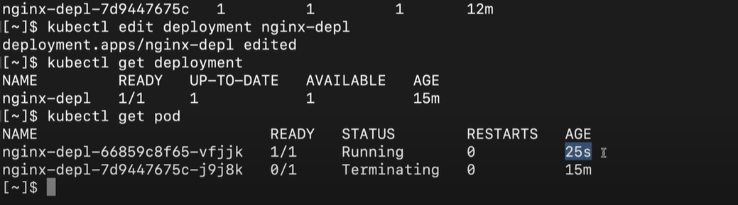



To check logs

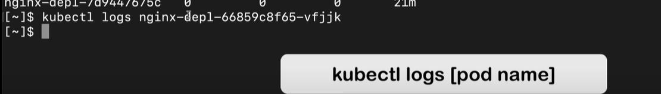

kubectl describe pod <podname> - gives additional information about the pod

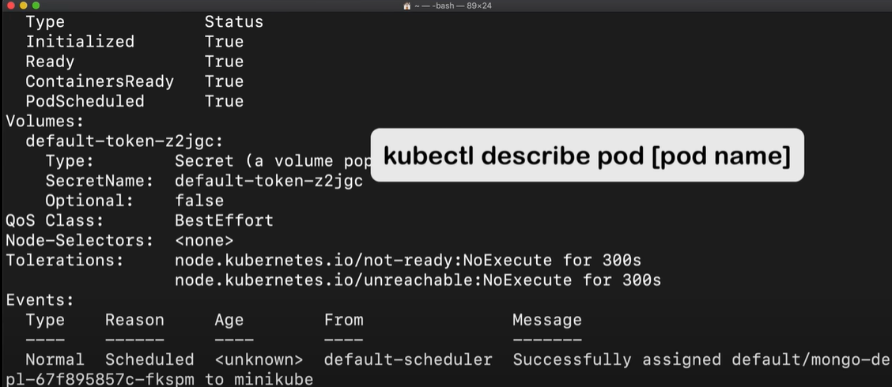

To get into interactive mode of any particular pod

kubectl exec -it <pod-name> --- bin/bash

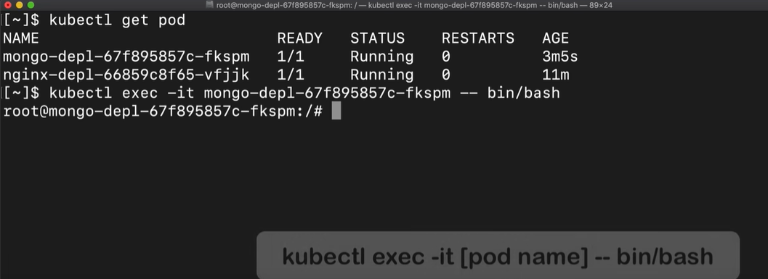

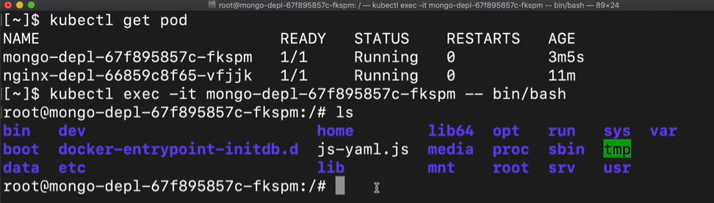



kubectl deletedeployment <deployment name>

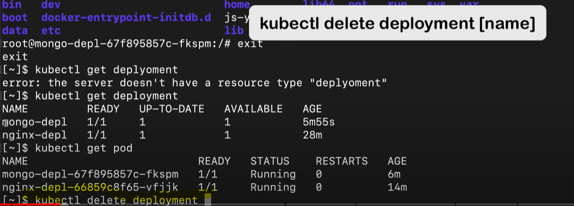

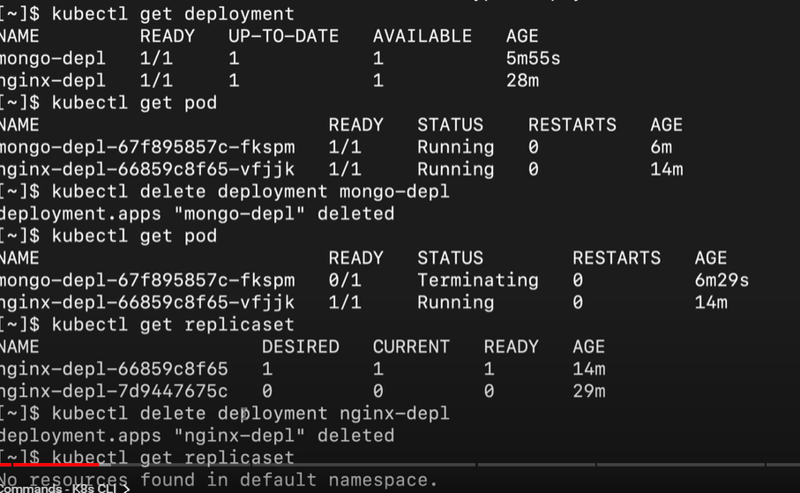

kubectl apply -f <name of config file> : command to apply configuration instead of having all options in a big kubectl

command

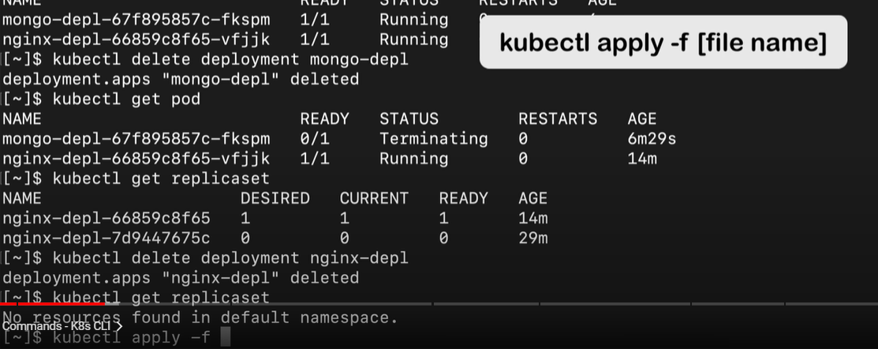

Basic config.yaml file

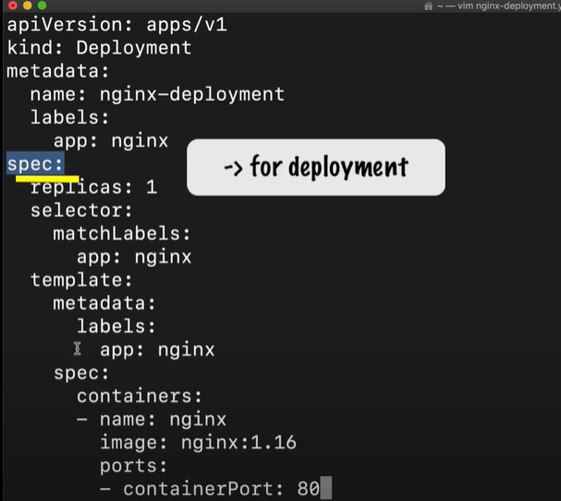

Applying the configuration

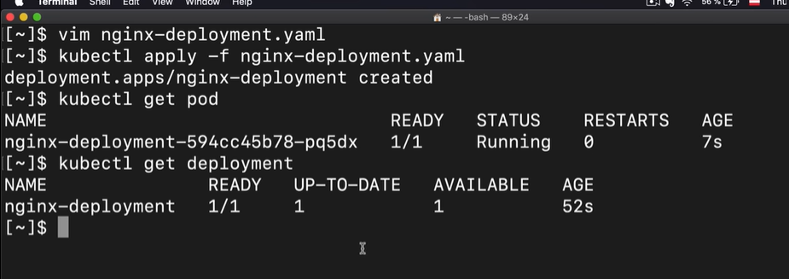

Edit the config file, by changing the replicas to 2 and apply it again

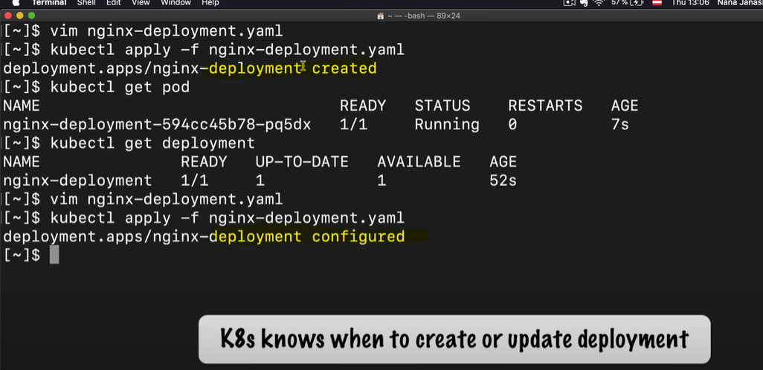

After updating replicas to 2

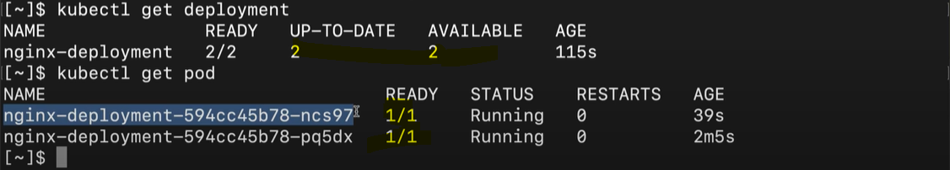

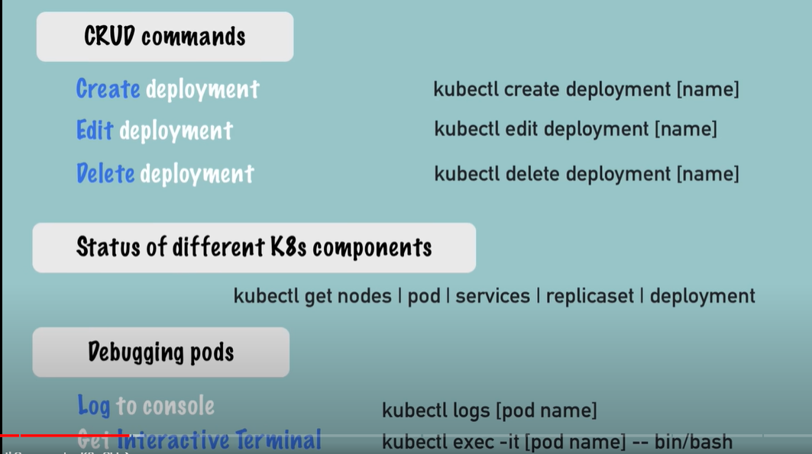

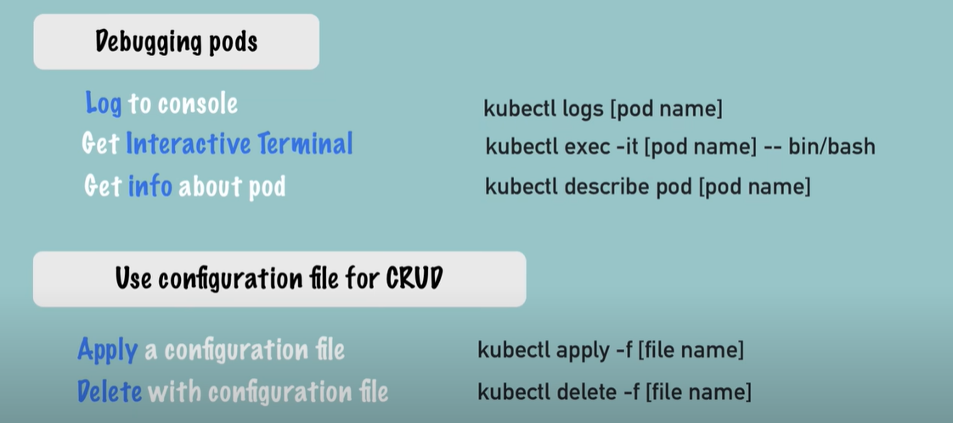

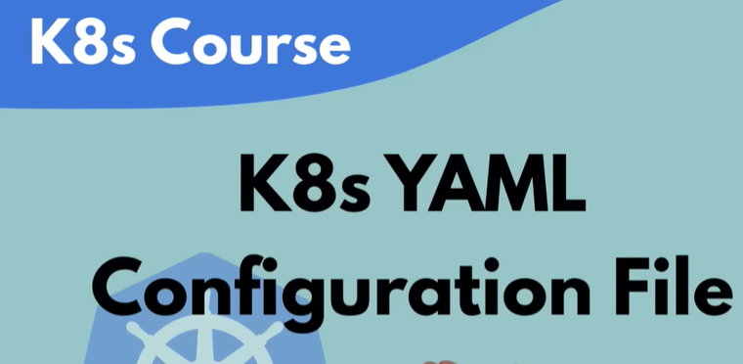

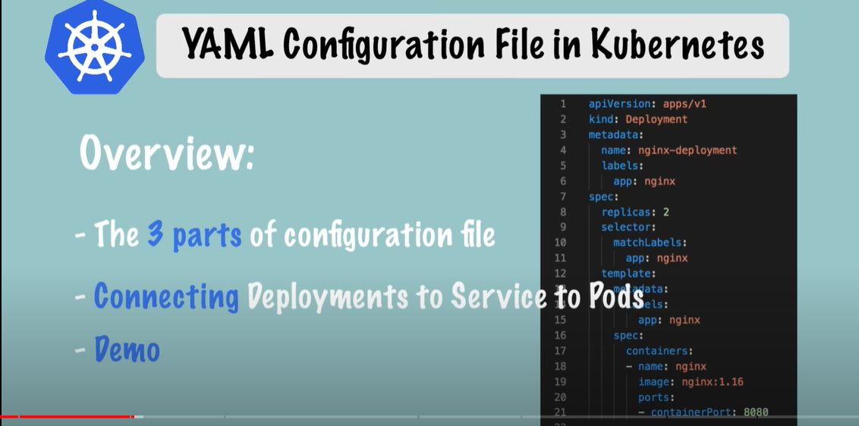



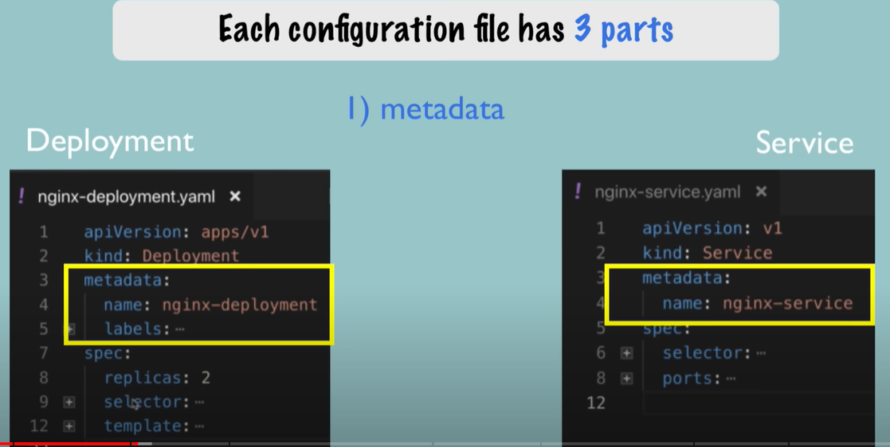

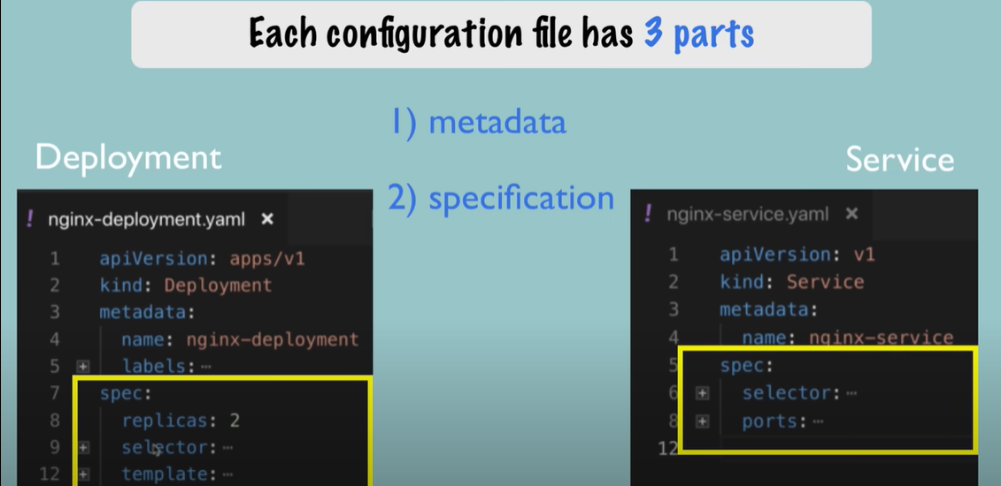

First 2 line describe what we want to create, either a deployment or a service

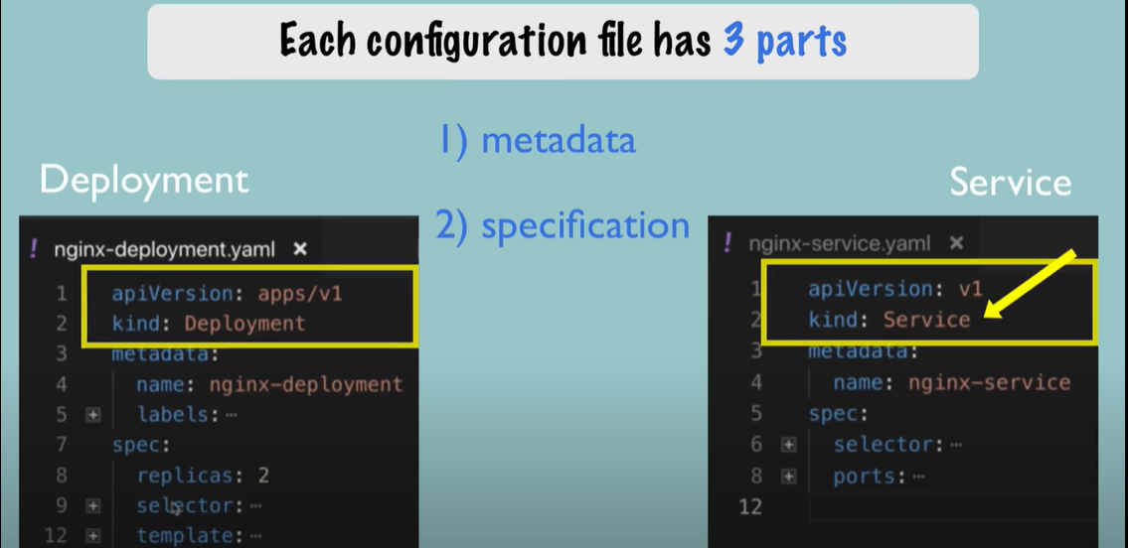

Inside specification(spec) , attributes will be specific to kind of component we are creating.

Deployment will have its specific attributes and so the Service

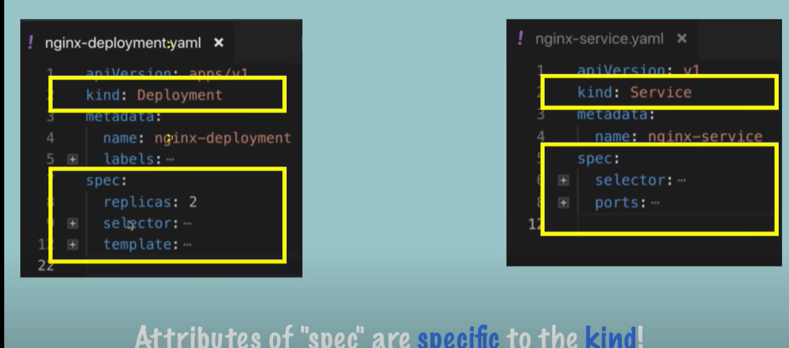

The 3rd part 'Status' will be automatically generated and added by kubernetes

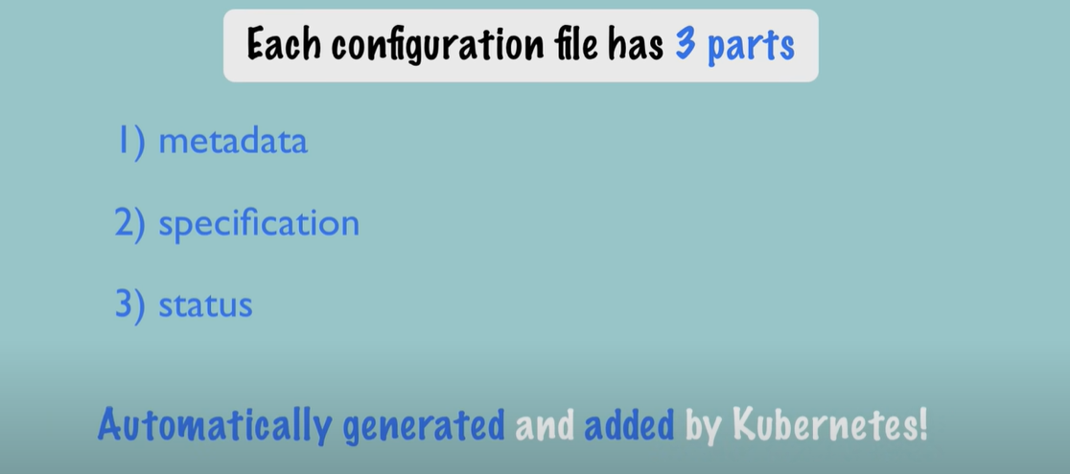

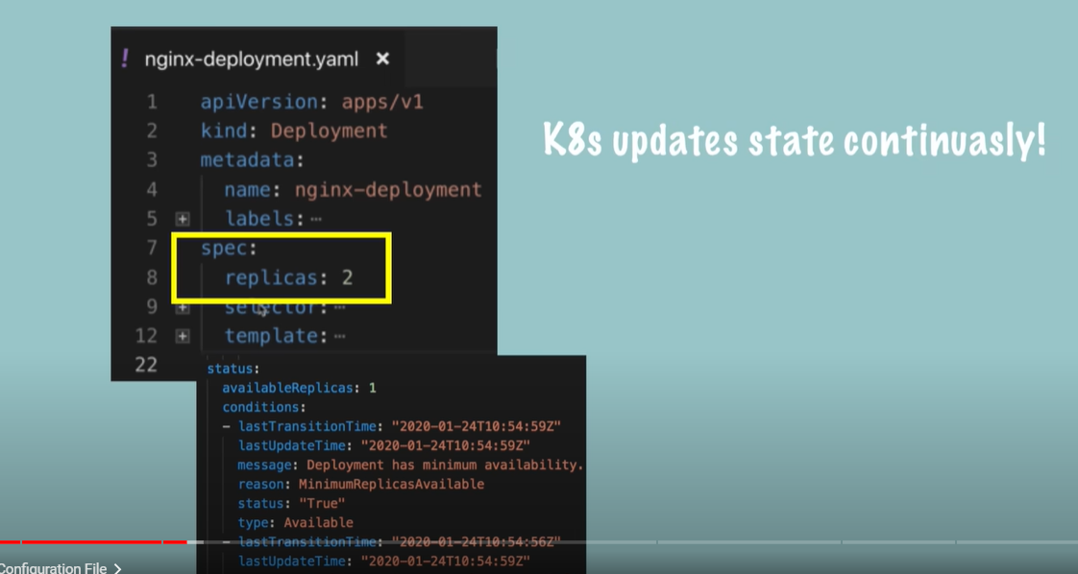

Continuously checks status. Ex: replicas should be 2, but it is 1 in below image. So it will add one more pod

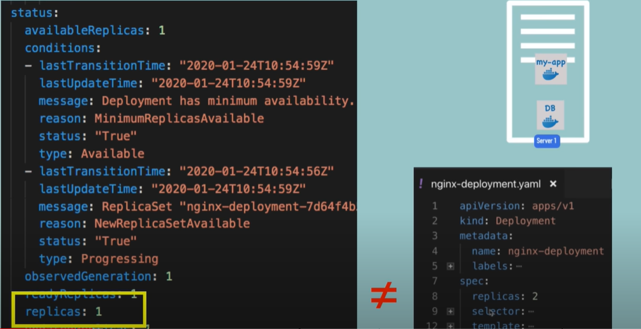

Kubernetes gets the status of any component from **etcd**

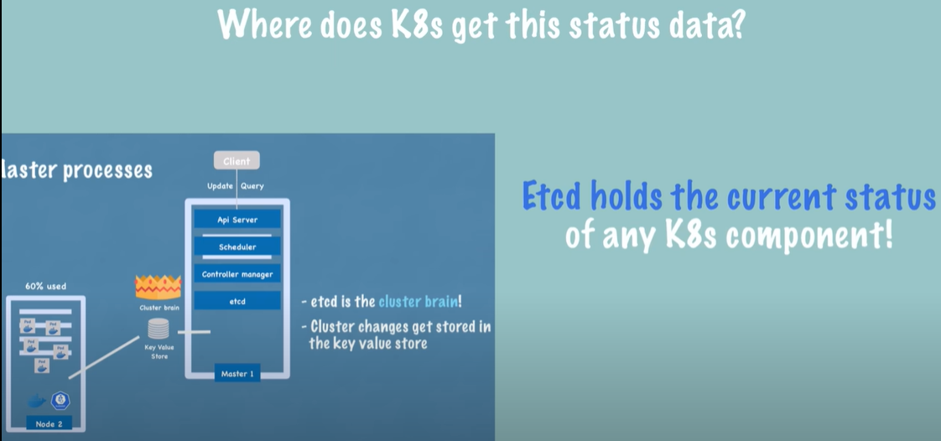

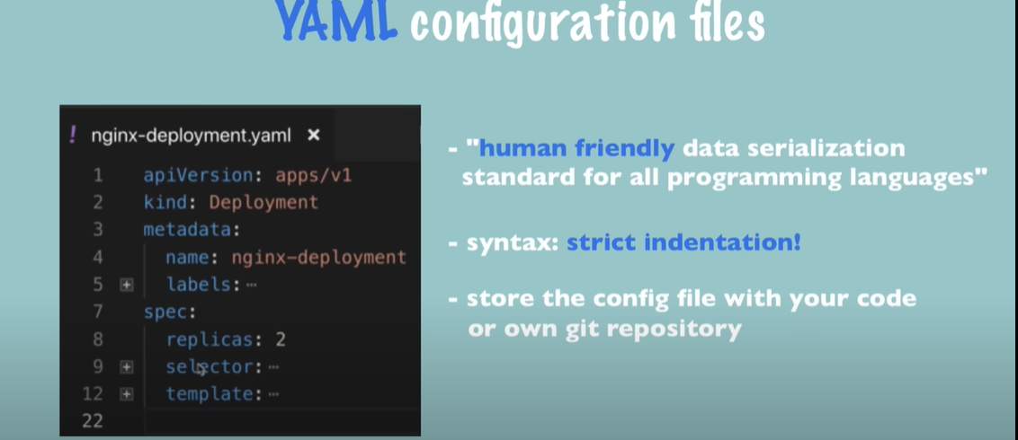



Pod details are mentioned under 'template' section of yaml file

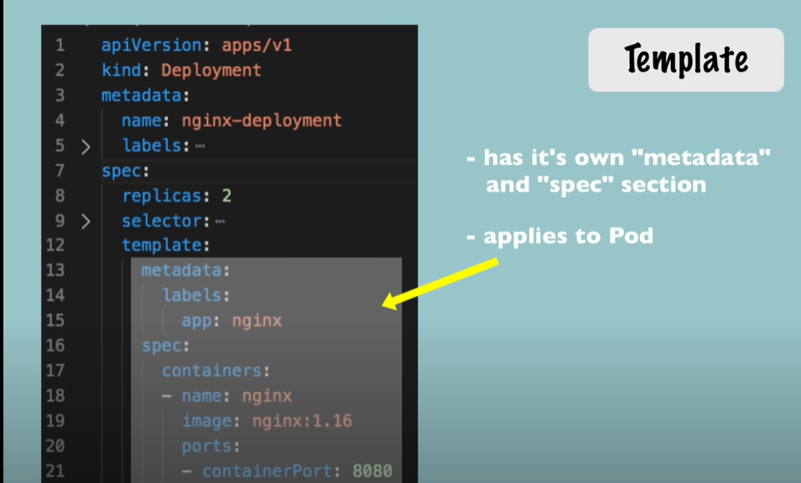

'spec' section under 'template' is the blueprint for the pod

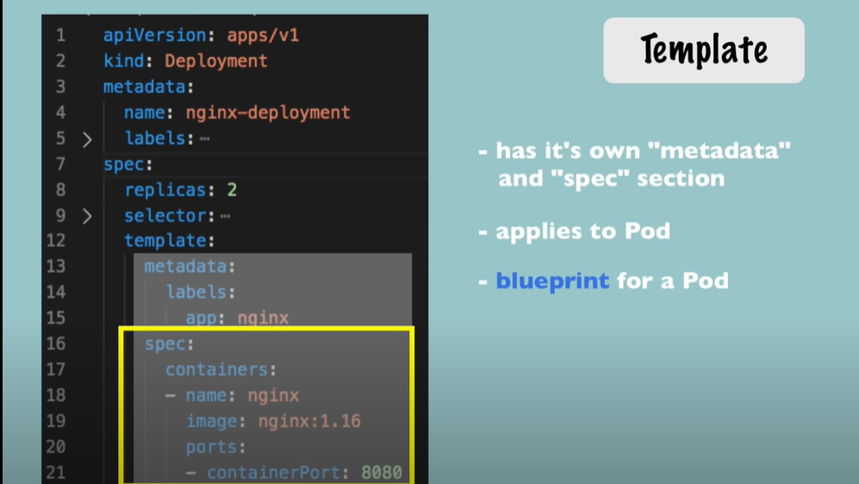



Connection between components is established using labels and selectors

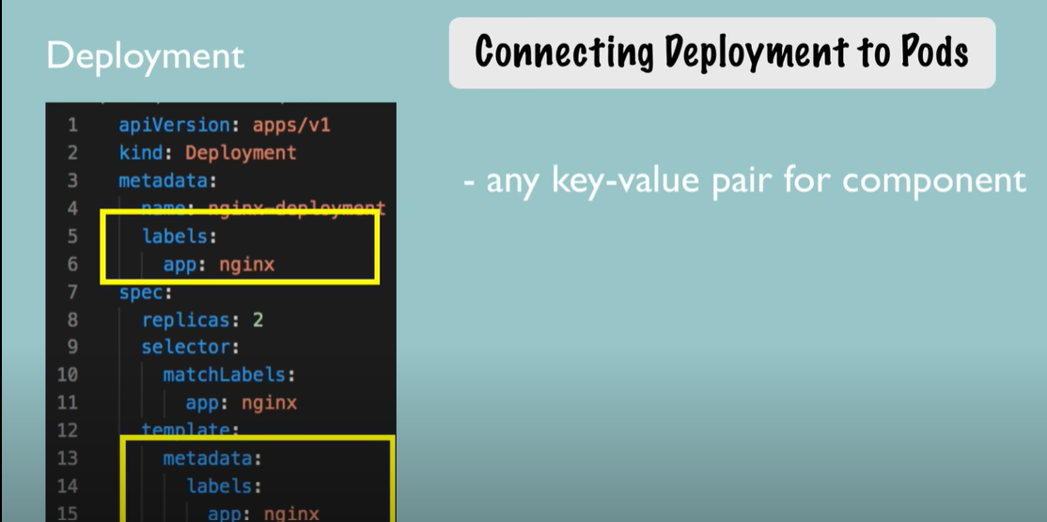

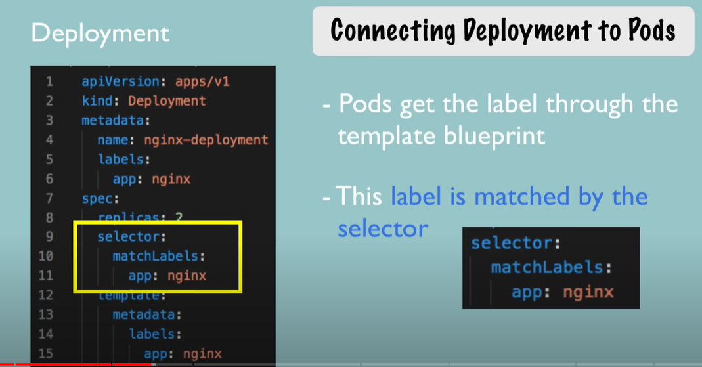

Deployment has its own label. This label is used by the service selector in the specification of service which makes a

Connection between service and its deployment/pods.

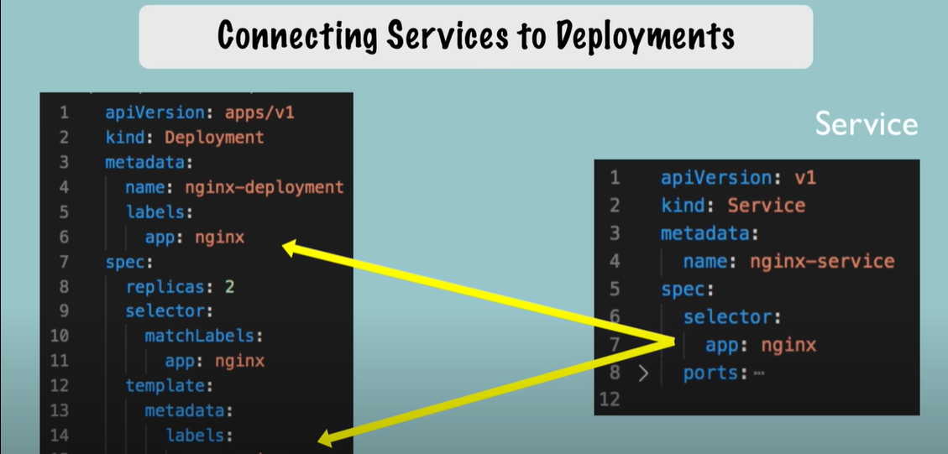

We also need to configure ports for both deployment and service

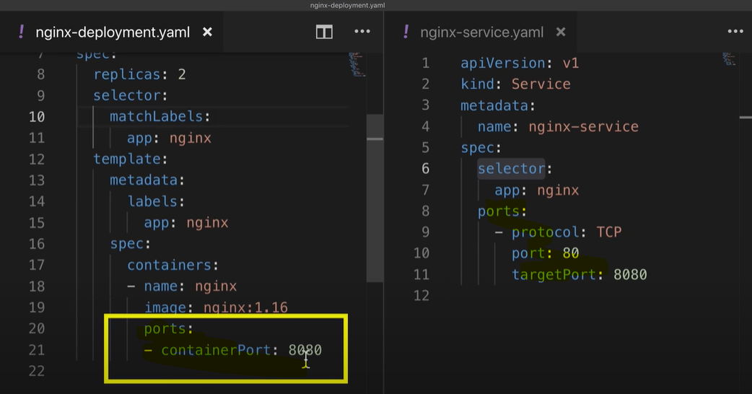

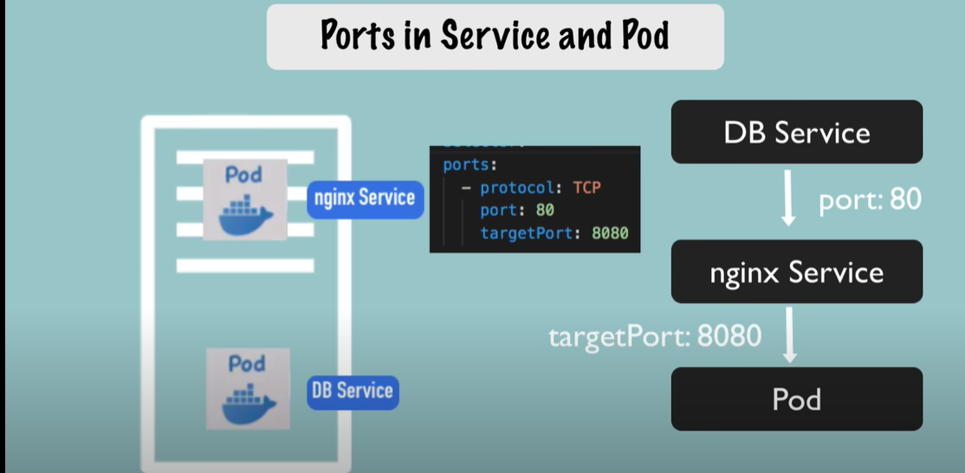

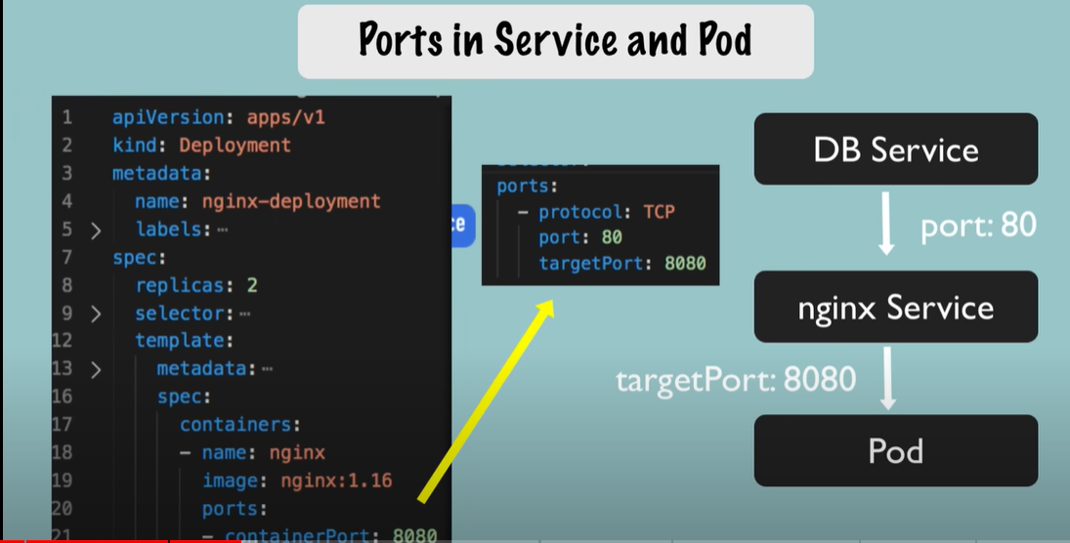

Config is done. Now create deployment and service using commands

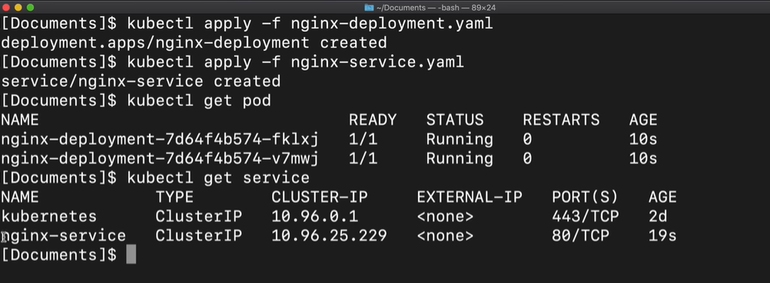

Command to validate that the service has the right pods that it forwards the requests to.

Below highlighted are the IP addresses and ports of the pods that the service will forward the requests to.

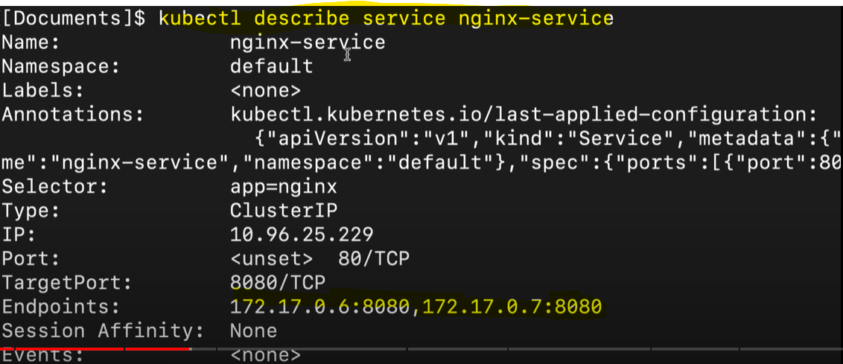

Command to get more details of pod like IP address etc

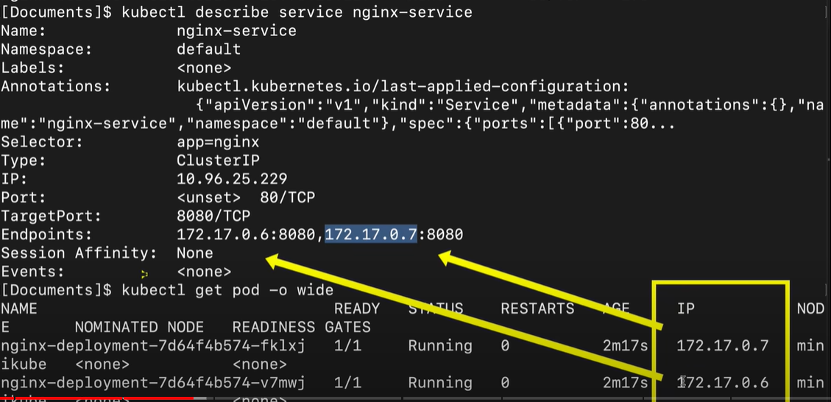

To delete the config file

